Edmonton Minor Soccer Association
Indoor 2020 – 2021 Season

Team Official Handbook
U9 – U19 Teams Only

Please note there may be other COVID related rules, regulations and policies that my circumvent information in this booklet. Please visit the EMSA website under Indoor Season Info for more COVID information.
This book is an excerpt of our rules, regulations and policies. For the complete listing of EMSA Rules & Regulations please visit:
www.emsamain.com

Table of Contents
Team Correspondence Page 2
Edmonton Minor Soccer Contact Information Page 3 Electronic Game Sheets…………………………………………………………………………………………………………Page 4 One time Jersey Number Entry…………………………………………………………………………………………………Page 5 How to Print Game Sheets………………………………………………………………………………………………………Page 6 Game Day Sheet Procedure…………………………………………………………………………………………………….Page 7
Scoring Games on the EMSA Website Page 8
Game Sheet Submission Page 12 Incomplete Game Sheets Page 12
Administration Fees Page 12
Referee Liaison Program Page 13
Team Spectators & Player’s Parents Page 13
Referee Feedback/Issues/Complaints/Compliments Page 13
Team Officials on the Bench Page 14
Bench Parents/Attendant Page 14
Players Registered and Dressed Page 15
Injured Player on the Bench Page 15 Guest Players/Trialists Page 15
EMSA I.D. Cards (Players/Coaches) Page 16
COVID Player/Team Official Card Procedure Page 17 How to Download an Electronic List or paper Copy of all your EMSA I.D Cards Page 18 Equipment, Casts, Splints and Jewelry Page 18
Game Length & Time Outs Page 19
Late Arrivals and Failure to Show Page 19
Rescheduling of Games Page 19
Winter Driving Conditions Page 20
Scheduling for Multiple Rounds Page 20
Harassment Page 20
Post Season Information Page 20
Player Transfers/Registrations Page 20
Facility Locations Page 21
Facility Passes Boarded Teams Page 21 Facility Passes NON- Boarded Teams Page 21
Personal Field Bookings & Gym Practices Page 21
Camera Policy Page 21
Discipline Page 22
Red Cards & Suspension Notifications Page 22
Violating Suspensions Page 23
Protesting Game Results Page 24
Appeal Procedure Page 24
Tie Breaking Procedure Page 25
Codes of Conduct Page 27

Team Correspondence Liaisons

We are advising all coaches, assistant coaches and managers that they will be the acting correspondence liaisons for their team.

They will be responsible for communications between the EMSA and the team. Such communications can include, but are not limited to suspensions, complaints, league play, etc.

Please note that only these individuals as well as the referee liaison will have the authority to contact the EMSA directly either through a phone call or email.

*Any other contact from parents, players, etc. will not be responded to.

Please follow the EMSA Communication Process listed below before calling/contacting the EMSA Main Soccer Office directly.

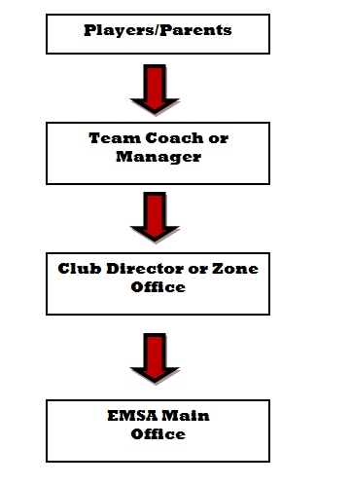

Contact Information
Office Location:
6520 Roper Road
Edmonton, AB T6B 3K8
Phone: 780.413-EMSA (3672)
Fax: 780.490.1652
General Office Hours: Monday – Friday 8:00am – 5:00pm (subject to change)

EMSA OFFICE STAFF
Dragos Niculescu – General Manager
dragosn@emsamain.com
780.916.7977 (text or phone)
Angela DiCesare – Club & Mini League Director
angelad@emsamain.com
587.334.2949 (text or phone)
Jenna Davis – Community Program Director
jennad@emsamain.com
587.340.3674 (text or phone)
Martina Menaguale – Registrar
martinam@emsamain.com
587.338.8316 (text or phone)
Leonora Newell – Office Administrator
leonoran@emsamain.com
587.357.3775 (text or phone)
Nichole Dunlop – Carey – Admin Assistant
nicholed@emsamain.com
780-413-3672 (text or phone)

EMSA REFEREE AND TECHNICAL DIRECTOR
Ed Charpentier 780.405.8960 text or phone
technicaldir@emsamain.com

EMSA EXECUTIVE
Mario Charpentier – EMSA President
president@emsamain.com
Jay Ruptash – EMSA Vice President
jayr@emsamain.com
Alisa Colmer – EMSA Treasurer
alisac@emsamain.com
June McNeil – EMSA Executive
jkhmcneil@gmail.com
EMSA DISCIPLINE DIRECTOR
Jay Ruptash
jayr@emsamain.com
EMSA CLUB DIRECTOR
Diana Clark
dclark.4@shaw.ca
*For a complete listing of the EMSA Board of Directors, as well as, Zone Office contacts visit the EMSA website www.emsamain.com

SOCCER CENTRE CONTROL/ADMISSIONS DESK CONTACTS
West Centre: 780.944.4092
East Centre: 780.413.4125 ext. 232
South Centre: 780.490.0158
Electronic Game Sheets
EMSA has moved away from the traditional game book game sheets and is now implementing an electronic game sheet download instead!
• There will now only be one “master” game sheet per game (1 piece of paper) and the HOME team will be responsible for logging into the EMSA Portal and printing off the “master” game sheet for each home game. The Away team does NOT need to print a game sheet. Both teams information will be on the same game sheet. If the home team forgets the game sheet then the home team will default the game and an administration fee of $100.00 will be issued to the team. For emergency cases, there will be a blank game sheet available for download on the EMSA website. We recommend, printing off a few
copies and keeping them with your game supplies.
• The following information will be auto-populated for both teams on the “master game sheet” by the EMSA Portal system:
- Date
- Game Time
- Field
- Division
- Home Team Name
- Away Team Name
- All Player’s Names (First & Last) and I.D. #’s
• For the player Jersey number’s:
Coaches need to log into their EMSA Portal account only once prior to the season beginning and add their player’s jersey numbers next to the player’s names. Once this is done, the player’s jersey numbers will auto populate for all future games.
• Teams will still need to handwrite in the following information onto their game sheet:
- Team Officials names and I.D. card numbers (EMSA currently does not limit the amount of team officials that can be on a roster so we cannot auto-populate this section as we don’t know who will be on the bench for each game).
- Bench Attendant name (if applicable)
- Ref Liaison name
- Team Official Signature

One Time Jersey Number Entry
Prior to the season commencing, a team official who is on the Portal roster must log into the EMSA Portal and enter all of their player’s jersey numbers into the system. This only has to be done once at the start of the season, not for every game. You can go back in and edit as necessary if player’s jersey numbers change or if you add a new player.
• Step 1: Log Into the EMSA Portal and click on the “Edit Player Jerseys” button in the Team Official Control Panel:
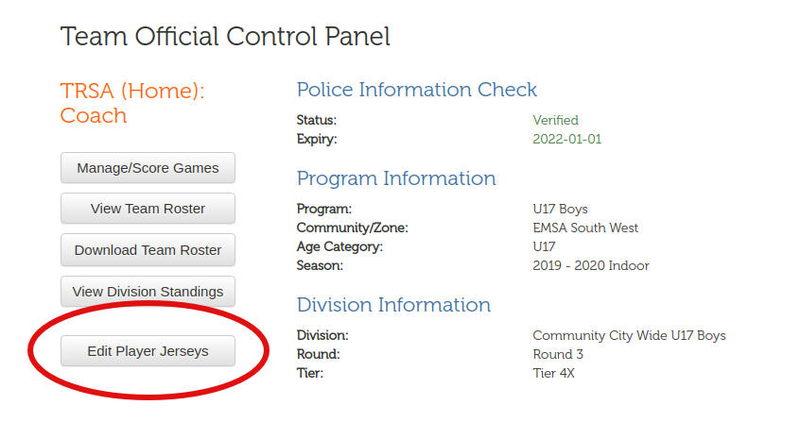
• Step 2: Fill in the “Jersey” field with a 1 or 2 digit number. Leading zeroes are preserved (e.g., 09 isn’t converted to 9). Leaving the field blank will remove the jersey number from the player. Repeat for the other players. Note that it’s possible to leave 1 or more players without jersey numbers; the U4s don’t need jersey numbers.
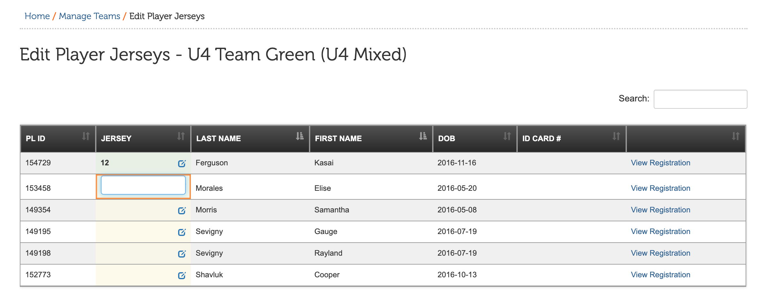
Once this has been completed, your player’s jersey numbers will now auto-populate on your electronic game sheets.
How to Print Game Sheets
The HOME team is responsible for downloading and printing one copy of the “Master Game Sheet”. Both team’s game information will be on the ONE master game sheet. Please see other Memo regarding Game Sheet instructions on what both teams need to do to complete their section of the one Master Game Sheet.
The Away team does NOT need to print a game sheet.
• Step 1: Log Into the EMSA Portal and click on the “Manage/Score Games” button in the Team Official Control Panel:
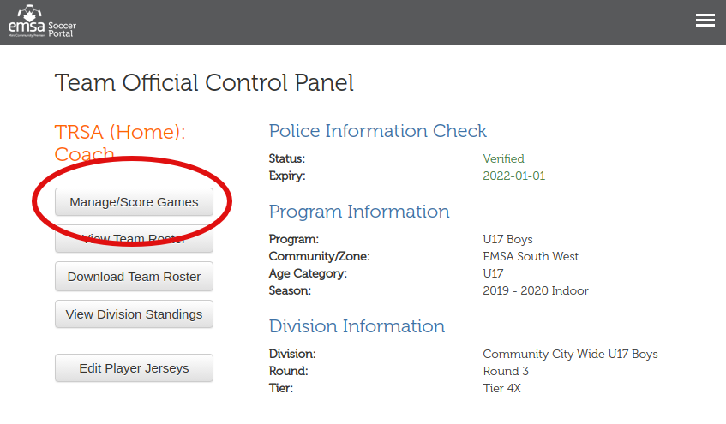
• Step 2: Find the game in the table and click the “Download” link under the “Game Sheet “column and the game sheet will automatically download. NOTE: ONLY the HOME TEAM will be able to download the “Master Game Sheet”.
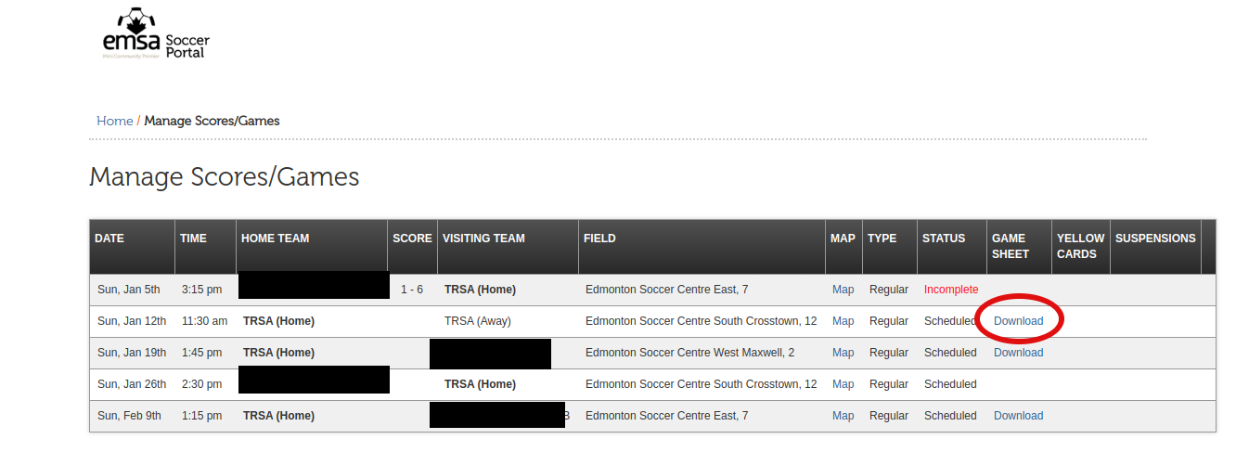
If the home team forgets the game sheet then the home team will default the game and an administration fee of $100.00 will be issued to the team. For emergency cases, there will be a blank game sheet available for download on the EMSA website under “Indoor Season Information”. We recommend, printing off a few copies and keeping them with your game supplies just in case.

Game Day Game Sheet Procedure
• The Home Team will be responsible for printing off one (1) copy of the master game sheet. If they do not have the master game sheet with them at the game it results in a default loss for their team and a $100 administration fee. If needed blank game sheets will be available for download and use from the EMSA website.
• Home team will need to write the following information onto the master game sheet in their section:
- Team Officials names and I.D. card numbers (EMSA currently does not limit the amount of team officials that can be on a roster so we cannot auto-populate this section as we don’t know who will be on the bench for each game).
- Bench Attendant name (if applicable)
- Ref Liaison name
- Team Official Signature
- Any players who are not present at the game but are listed on the game sheet need to be crossed off
• When the home team arrives to the Facility they find and pass the master game sheet to the away team prior to going out onto the field of play.
• The Away team will need to write the following information onto the master game sheet in their section:
- Team Officials names and I.D. card numbers (EMSA currently does not limit the amount of team officials that can be on a roster so we cannot auto-populate this section as we don’t know who will be on the bench for each game).
- Bench Attendant name (if applicable)
- Ref Liaison name
- Team Official Signature
- Any players who are not present at the game but are listed on the game sheet need to be crossed off.
• Once the away team has completed their portion of the game sheet, they hand it back to the home team.
• If there are any players missing off the game sheet, teams can handwrite their names and info in. However, ensure they are on your Portal roster first before playing them.
• For this season, due to COVID, the team officials will check each other’s players and team officials I.D. cards.
• The home team then presents the game sheet to the referee PRIOR to kick off .
• At the end of the game, the referee will keep the master game sheet and any other forms and hand it into the EMSA office.
• There will be no carbon copies of the game sheets so if either of the teams or the referees would like a copy of their game sheet, they will have to take a photo of it with their cell phone or other device.
• For rescheduled games, the home team will need to reprint the game sheet from the new date that the game is scheduled for once it has been rescheduled and confirmed in the EMSA Portal.

How To Score Games In the EMSA Portal
***U9 Community teams are not required to post the score at the end of their games no stats are recorded for their league games.
***U11 Community teams please post the mercy score for your game.
U9/U11 Club Teams, please post your scores and use the Mercy Rule (no more than a 5 goal difference) when you enter the score in the EMSA Portal.
U9 – U19 Only
Teams must choose the coach, assistant coach, or manager (as listed on the EMSA Portal roster), to be responsible for scoring the game results online.
Scoring the game online is the responsibility of the HOME TEAM. Game results must be input online by 1:00 PM the following business day. Failure to do so will result in an administration fee being issued to the head coach of the HOME TEAM.

Instructions for Scoring Games
- Go to www.emsamain.com and click on the Coach Login link at the top of the page:
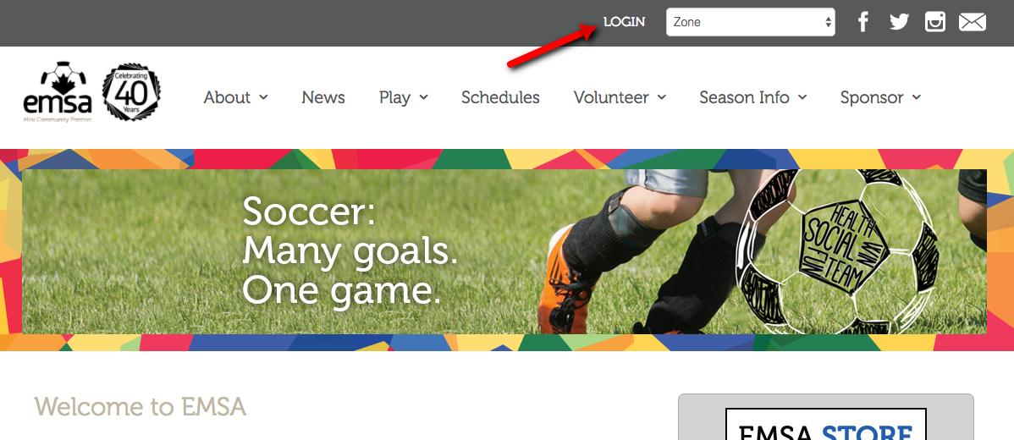

- Please sign in with your account.
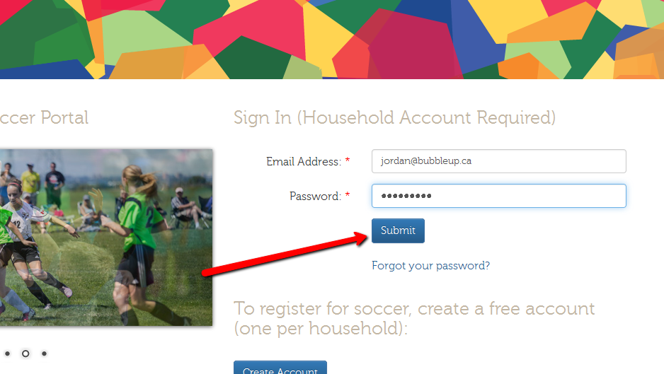

- Select the Team Official role for the team you are coaching. A person may have multiple team official roles (1 role per team). In this example, a McLeod coach with last name Johnson is signing in.

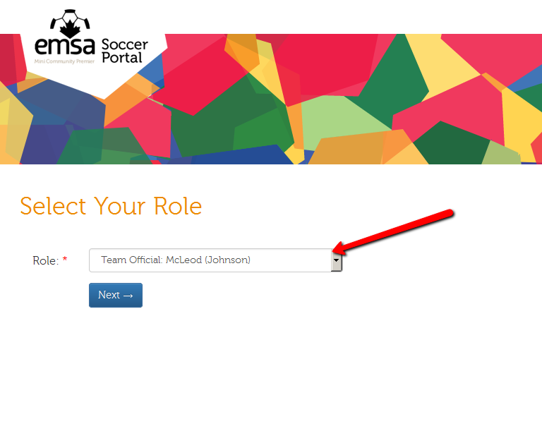

- Once signed in, you will be redirected to the Team Official Control Panel. Click the Manage Score/Games button.
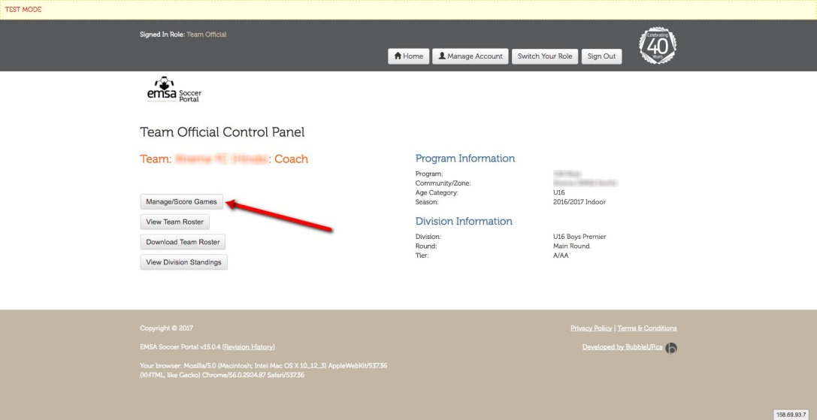

- On the Manage Scores/Games screen, you will see a list of all games for your team. Once a game is ready to have a score recorded, an edit pencil button will be available. Click the edit pencil button.
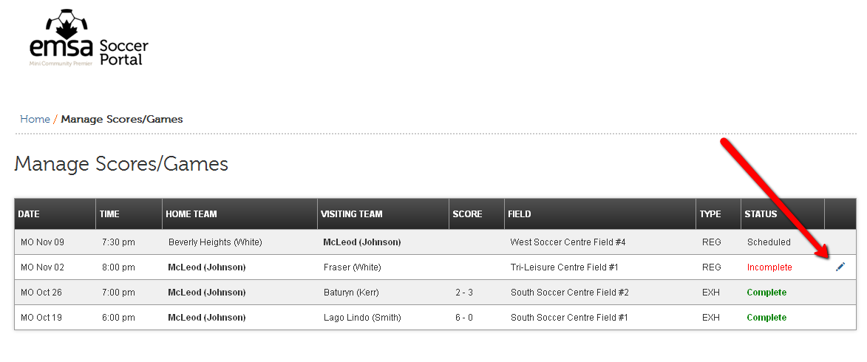

- On the Score Game form, complete the required fields by entering the home team score and the away team score.

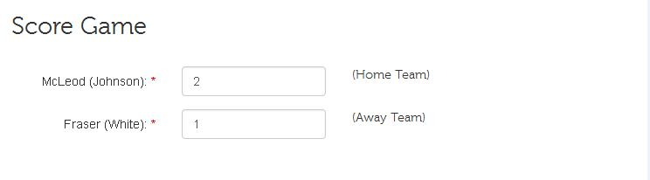
- Lastly, please submit feedback regarding the referee officiating of the game. There are 6 questions to be completed and an option to provide comments. (this is optional)
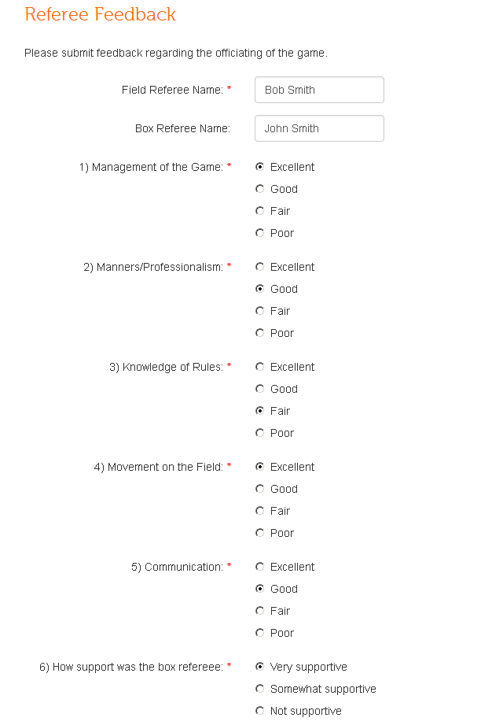
- Once the form is complete, click the Submit button.
- After submission, the game status will be changed to Under Review. An EMSA Administrator will review the game sheet and verify the information has been collected and acknowledged.
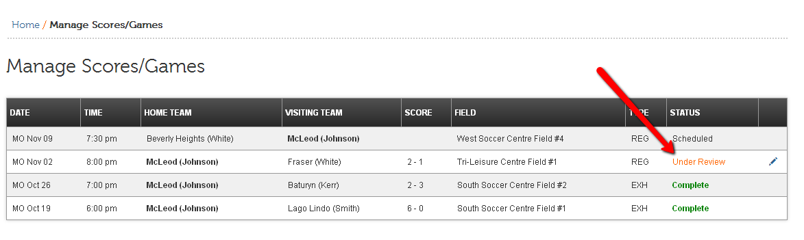

- If the Administrator verifies the game, the status will be marked as Complete. However, if there is an issue with an uploaded/faxed game sheet, an email will be sent back to the coach asking for the game sheet. In this case, the status will be changed to Information Required.
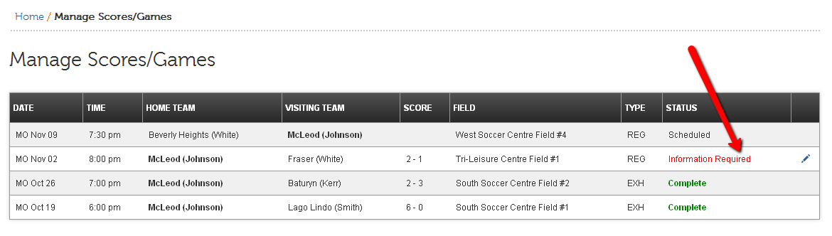
Game Sheet Submission
For the indoor season, the referee will keep the master game sheet and the referee will submit it to the EMSA office on the teams’ behalf. There are no carbon copies of the master game sheet so if you would like to have a copy of the game sheet for yourself, please take a photo with your phone.

Incomplete Game Sheets
Please ensure your section of the master game sheet is completely filled out as required. Otherwise, administration fees are issued for incomplete game sheets. Please see the Game Sheet Procedure on the EMSA website or in your team official handbook to know what areas of the game sheet are required to be filled in manually by the team officials prior to game start.

Administration Fees
Offense | Fee Amount
Incomplete Gamesheet | $50.00
Failure to Score Game Results by 1:00 PM | $75.00

Referee Liaison Program
The abuse of game officials by coaches and spectators is the main reason why referees (especially those in their early teens) drop out of the development program. As a result, we face severe shortages of game officials at all levels. Addressing this unacceptable behavior is a top priority for EMSA, particularly if minor soccer is to have an adequate supply of referees.
Both Home and Away teams, participating in the U9-U19 community and U9-U19 Club programs, are required to provide a referee liaison for every EMSA league game. The referee liaison can be any person over the age of 18, with the exception of the teams registered coaching staff. The referee liaison can be a different person each game and their name must be PRINTED on the game sheet in the space provided. The referee liaison must wear an identifying neck lanyard and sit in a visible area in the stands with the spectators.
The referee liaison must be an individual who is willing and able to control and monitor the behavior of the parents and coaches throughout the game. This role is to be taken very seriously and the goal of this role is to keep the parents and coaches in the game following the rules as set forth in code of conduct as well as maintaining respect for the referees and opposing team. This role is not in place for the referee liaison to question any calls made by the refs.

Description of Duties
- Wear the referee liaison neck lanyard – this is to be provided by a team official.
- Place yourself in the middle of your team’s spectators.
- Monitor the behavior of your teams’ spectators and coaching staff.
- Quickly diffuse potential issues before they escalate by either making your presence more visible, or calmly addressing the behavior with the person(s) involved.
- Address inappropriate comments, gestures, and/or any other unsporting behavior directed at the game officials, players, coaching staff or any other individual by your teams’ spectators.
- Submit a brief report in writing, outlining any incidents involving any individuals, to the referee after the game. This will be turned into the EMSA League Director and they will conduct an investigation at their discretion.
Failure to provide a referee liaison will result in a default win for the opposing team. All teams are granted a 15 minute grace period to provide a referee liaison.

Team Spectators & Player’s Parents
The head coach of the team is responsible for all spectators and player’s parents associated with their team. Please keep in mind that the head coach may serve a suspension for any issues that arise from the team’s spectators/parents. Please ensure you speak to your group about their behaviour in the stands or at the soccer centres ahead of time.
Referee Feedback/Issues/Complaints/Compliments
Please contact the EMSA Referee Director, Ed Charpentier at technicaldir@emsamain.com
Team Officials on the Bench
- The EMSA regular season league play permits a maximum of four (4) team officials on the bench, one of which must be of the same gender as the team’s players.
- Some Tournaments only allow a maximum of three (3) team officials on the bench and teams must adhere to each individual tournament rules.
- All Team officials (coach, assistant coach & manager) in the U9-U19 Community Program and ALL U9 – U19 Premier/Club League team officials (coach, assistant coach & manager) must produce an EMSA I.D. card (or an electronic version) to be permitted on the bench. If you cannot produce an EMSA I.D. card prior to the start of the game you will not be permitted to be on the bench and you must sit with the spectators for the duration of the game. No other forms of I.D. will be accepted. If a team official participates without their ID card (or electronic copy) the team will default the game and the team official is suspended.
- If Team Officials forget their ID Card or cannot show it electronically, they are NOT permitted to be marked down on the game sheet as a bench attendant. If this is done, it is considered participating without their I.D. card and the game will be forfeited and the coach suspended.
.
Bench Parent/Attendant
- If you have a team official on the bench and listed on the game sheet that is the same gender as the team, then it is not mandatory that you have a bench attendant. You can still have a bench attendant if you wish to help out but they can be any gender.
- If you do not have a team official on the bench that is the same gender as the team, then it is mandatory that you have a bench attendant that is the same gender as the team.
- In situations where females play or trialist on boys’ teams the team must include at least one female team official or bench attendant on the bench.
- Bench attendants must be at least 18 years of age.
- One bench attendant per game is permitted.
- At no time can a registered team official on your team (coach, assistant coach or manager) be written down on the bench attendant line of your game sheet. If a person is a registered team official that appears on your EMSA Portal Roster, then they must be marked down on one of the team official lines. The bench attendant line is only for those individuals helping out who are NOT on the roster.
- If a team official forgets their I.D. card (or electronic copy), they cannot be marked down as a bench attendant instead. They must sit in the stands for the entire game.
- The bench attendant is included in the 4 maximum non–playing personnel on the bench. This means if you are using a bench attendant, then you can only have three (3) other team officials on the bench as the bench attendant would be the 4th.
- Bench attendants do not need an EMSA or District I.D. card, but they have to show a form of government issued photo I.D. to the referee to prove their identity for those divisions that require I.D. cards.
- If the bench attendant is removed from the game by the referee due to misconduct, the head coach or the bench attendant will serve any suspension issued.
- It is recommended that the bench attendant attend to any injured player on the field, however any team official (regardless of gender) is permitted to assist the injured player once given permission to enter the field from the referee.

Players Registered and Dressed
Teams are limited to a maximum number of players permitted to be registered & dressed at one time during the season, according to the following:
- U7 *12 players (*due to COVID)
- U9 & U11 Comm *12 players (*due to COVID)
- U13, U15, *12 players (*due to COVID)
- U17, U19 Comm 20 players
- U9 & U11 Club 16 players
- U13, U15, U17, U19 Club 20 players
*Note: U9 and U11 Boarded teams will play 7 per side (6 players & 1 keeper) for the indoor season.
*Note: U9 and U11 Non Boarded teams will play 8 per side (7 players & 1 keeper) on a 7v7 size field.
**Teams are permitted to dress and play additional players only if they have received special dispensation from the EMSA Board of Directors.
Minimum Amount of Players Required to Start Game:
Age Group | Minimum Number of Players Required
U7 | 3
U9 & U11 | 5
U13 – U19 | 4
U9 – U19 Non Boarded | 7

Injured Players on the Bench
Players who are on the team’s roster but are currently injured may still go onto the bench to support their team. They must be dressed in a jersey with a number, their information must be included on the game sheet and the letters “INJ” should be noted on the game sheet beside their name.

Guest Players/Trialists
ONLY Community Teams are permitted to use guest players for this season as long as they are from a team that is in their same cohort. A trialist form must be filled out and sent in along with the game sheet.

EMSA I.D. Cards (Players/Coaches)
The following EMSA city wide programs require an EMSA I.D. Card:
• Players:
Age Group | Community | Premier A | Premier B | Tier 1 | Tier 2 | Tier 3
U9
U11
U13
U15
U17
U19

- Should a player be without their player card at kickoff, they may play the game provided that their player card is presented to the game official prior to end of the game. Failure to present the players EMSA I.D. card to the game official prior to the end of the game, will result in a default loss for the team. The player and team will also be subject to further disciplinary action being taken by the EMSA Discipline Committee.
- Out of District players are permitted to use their own youth District I.D. cards in place of EMSA cards as long as their District has received permission from the EMSA office.
*Note: there is a $20.00 charge for any replacement EMSA I.D. cards, where the card has not expired.
• Team Officials: (head coaches, assistant coaches and managers):
Age Group | Community | Premier A | Premier B | Tier 1 | Tier 2 | Tier 3
U9
U11
U13
U15
U17
U19

- NO other forms of identification will be accepted for team officials. They must have an EMSA or District ID card.
- Team Officials who are unable to present their EMSA I.D. cards prior to the start of the game will not be permitted on the bench and must sit with the spectators for the entire game. If no team officials are able to produce their EMSA I.D., the game will be recorded as a default loss and three (3) points and five (5) goals will be awarded to the opposing team.
- If a team knows ahead of time that it will be unable to supply the EMSA I.D. cards for the registered team officials, or if the registered team officials are unable to attend a game, the team may request that a substitute coach or coaches be granted permission to take control of the team temporarily. A request to allow for a substitute coach or coaches must be sent to the EMSA League Director and should the request be approved, they will provide a permission letter to allow the substitute coach/coaches on the bench. This permission letter must be handed to the referee prior to kickoff and will be kept for submission to the EMSA League Director along with the white copies of the official game sheet.
- A team official can use a picture of his/her EMSA I.D. card shown on an electronic device.
- Team officials CANNOT be written on the bench attendant line if they are unable to produce their ID card or electronic copy.
- If a team official participates in a game without their ID card then the team will default the game and that team official will be suspended for one game.
- Out of District team officials are permitted to use their own youth District I.D. cards in place of EMSA cards as long as their District has received permission from the EMSA office.
*Note: there is a $20.00 charge for any replacement EMSA I.D. cards, where the card has not expired.

COVID Player/Team Official Card Procedure
Prior to entering the field of play, team officials will now check/verify each other’s player and team official cards. The referee will not be verifying the cards for this season in order to remain outside of the cohort. If there is a discrepancy, please tell the referee when you pass them the master game sheet. The referee will either rectify the situation at the field or put a note on the game sheet for the EMSA Office Admin to review.
Please ensure a check mark is placed in the appropriate box on the game sheet next to the player’s names to indicate the card has been checked.
Please just mark a check mark next to the name of the team officials to indicate their cards have been checked. You can show your I.D. card(s) by one of four different ways now:
1. You can have the actual I.D. card on you and just hold it out at arm’s length during the check.
2. You can show the individual I.D. card electronically on a device by holding the device out at arm’s length during the check.
3. Team officials can now download an electronic list of all the team’s I.D. cards (if you use EMSA I.D. cards) that will appear on your phone and you can show the cards by scrolling through the list.
4. Team officials can now download and print the cards (if you use EMSA I.D. cards) that will appear all together on a few pieces of paper and show them this way.

How to Download an Electronic List or Paper Copy of all your EMSA I.D. Cards.
You can find the link to download the electronic list or print the cards on paper by logging into the EMSA Portal and click on “Download Team ID Cards”, see below. Please note that if your Club/District uses their own I.D. cards instead of EMSA I.D. cards this feature will not be available to you.
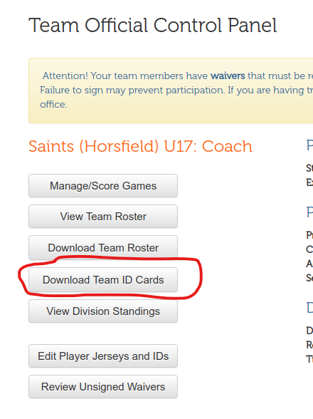
Equipment, Casts, Splints and Jewelry
- Indoor soccer shoes or runners are the only footwear permissible to be worn by players.
- It is at the discretion of the game official what will constitute dangerous equipment which must be removed in order for play to be allowed.
- Under no circumstance will splints and/or casts be permitted to be worn on the field during game play.
- Players who wear braces (knee, ankle, wrist etc…) will be permitted to wear these during game play provided that the brace does not have the potential to injure others. The decision to allow specific braces is left to the game official.
- Players refusing to remove any type of jewelry at the request of the referee, including all external body piercings, will not be permitted to play. Taping is not permitted.
- Referees have the final say as to what is considered a hazard.
- It is the responsibility of the Home Team to supply 3 (three) game balls as specified below:

Age Group | Ball Size
U7 | Size 3
U9 & U11 | Size 4
U13, U15 & U19 | Size 5

Game Length & Time Outs
- Boarded Games will consist of two (2) equal halves of *20 minutes for U9 – U19 (*Due to COVID).
- Non Boarded Games will consist of two (2) equal halves of 25 minutes for U9 – U19.
- Each team is entitled up to three (3) minutes of interval time per the referee’s discretion.
- For Boarded Games each team is permitted a maximum one (1) minute to be used as a timeout during the game. Teams may request this from the referee at any stoppage of play during the game. The game clock will stop and the referee will tally the time used against the one (1) minute allotted for the time out. Teams are not permitted more than one (1) time out per game, regardless of whether or not they used the minute provided. Time outs cannot be exchanged among teams.
- For Non Boarded games, no time outs are permitted.127
- Games are considered complete when they have been played to 2/3 of the game length.
Late Arrivals and Failure to Show
• Minimum Amount of Players Required to Start Game
Age Group | Minimum Number of Players Required
U7 | 3
U9 & U11 | 5
U13 – U19 | 4
U13 – U19 Non Boarded | 7
.
- A 10 minute grace period is provided for a team to be present. If a team is not present after such time, the game will be recorded as a default win for the opposing team and they will be awarded three (3) points and five (5) goals in their favor by the league director.
- In order to claim the default win, the team that is present must turn in their completed game sheet to the referee.
- Late players must arrive prior to kickoff of the second half. Players arriving after such time will not be permitted to play.
- It is not mandatory for the opposing team to wait any longer than the 10 minute grace period. After this time has expired, the field may be used for a practice or an exhibition game for the remainder of the time that was scheduled for the 55 minute game.
- In the event that both teams are not present, the game will be recorded as ‘cancelled’. These games will not be rescheduled.

Rescheduling of Games
All teams were given the opportunity to submit tournament requests to be taken into account in terms of scheduling, prior to the season beginning. As a result, the rescheduling of games during the indoor season is NOT permitted for any reason. Teams are required to play all of their games, as they are scheduled.

Winter Driving Conditions
Failure to travel to a scheduled game due to extremely poor road conditions, as advised by the local police/RCMP, will result in the game being brought to the EMSA Discipline Committee for review. The Committee will decide whether the game will be recorded as a default loss, or be rescheduled for play.
If your team is not present for your scheduled game due to the above mentioned circumstances, please send an email to the EMSA office right away via email and send a copy of the notice where the local police/RCMP advised to stay off the roads.
Club League Director: angelad@emsamain.com
Community League Director: jennad@emsamain.com
Scheduling for Multiple Rounds
Teams placed in groupings with multiple rounds are responsible for downloading their new schedule from the EMSA main website, as they will not be emailed to you. Please do not call the office inquiring about the next round schedule, as they are posted as soon as they are ready. Please allow your league director the time to confirm the stats and create the new schedules.
Harassment
EMSA has zero tolerance for any form of harassment, bullying, discrimination or intimidation. Any EMSA player, team official, game official, parent or other participant who engages in such behaviour towards another EMSA player, team official, game official, parent or other participant will be subject to discipline by the EMSA Discipline Committee.

Post Season Information
Post Season Information will be emailed to the team officials as soon as it becomes available. Teams are responsible for informing themselves on the post play information for their division.
*Note: Out of District teams are not eligible to participate in the post season Provincials competition through an EMSA berth. Out of District Community League teams, however, may participate in the EMSA City Finals. A post season commitment form must be submitted by the deadline to advance.

Player Transfers/Registration
The process of transferring/registering a player must begin with your zone office/registrar. Should further assistance be required, please contact the EMSA Main office. Players must self-isolate for 14 days prior to beginning any training, practices or games with their new team.
Player Transfer Deadline: February 15, 2021

Facility Locations
Field 1 – 4 Edmonton Soccer Center West 17415 – 106A Avenue
Field 5 – 8 Edmonton Soccer Centre East 12720 Victoria Trail
Field 9 – 12 Edmonton Soccer Centre South 6520 Roper Road
Field 13 – 14 Trans Alta Tri Leisure Centre 221 Jennifer Heil Way (Spruce Grove)
Q1, Q2, Q3, T1, T2 Edmonton Soccer Dome 3105 101 St SW

Facility Passes Boarded Teams- Edmonton Soccer Centres South, East and West
All players, U7 - U19, are admitted into the facilities for free and do not require a facility pass.
For Boarded teams, there will be decals distributed to the teams by your Zone Offices, to be used by the team officials. These will be placed on the back of the team officials EMSA I.D. card and used as the facilities admissions pass.
Should additional passes be required, they can be purchased at the admissions desk in each of the Edmonton Soccer Associations facility buildings. EMSA does not have extra facilities passes/decals and EMSA is not responsible for lost or stolen passes/decals. Should a pass/decal be lost or stolen, a replacement pass must be purchased at full price from one of the three Edmonton Soccer Facilities.
Parents & spectators are responsible for purchasing their own passes through the Edmonton Soccer Association Facilities at full price.
Non Boarded teams do not receive Edmonton Soccer Centre Facility Passes. If Non Boarded team officials wish to go to the Boarded Centres, they will need to purchase Facility Passes on their own at regular price through one of the admissions desks.
Facility Passes NON Boarded Teams – Edmonton Soccer Dome
Oct 15/2020: Information from the Edmonton Soccer Dome was not available at the time we published this handbook. Please visit the EMSA website and we will update the info as soon as it is received.
Personal/Practice Field Bookings & Gym Practices/Bookings
Edmonton Soccer Facilities manages the bookings for the Edmonton Indoor Soccer Centres. If you wish to book/rent a field, please contact them directly at 780.413.4125 ext. 1 or email bookings@esaf.com.
Camera Policy
As stated by the Edmonton Soccer Association Facilities Camera Policy:
Camera refers to all recording or image devices. Photograph/photo refers to all forms of captured images.
- Taking photos and/or recording videos is not permitted on the field, in the player/referee/penalty boxes, or from the hallways leading to the dressing rooms. In order to photograph from any of these areas, special permission must be obtained by the ESA Facilities management.
- Taking photos and/or recording videos is permitted from the lounge, bleachers/stands, and behind the Plexiglas on the main floor only after first seeking consent of the individuals being photographed/recorded. In the case of minors, permission must be granted from the child’s parent/guardian.
- Under no circumstances is it permissible to take photographs or videos in the dressing room and/or washrooms.
- Individuals violating this policy will be asked to stop and could face further disciplinary action including, but not limited to, fines, bans and bonds.
Should you have any questions or concerns, or if you are seeking special permissions for photography, please contact the Operations Manager at 780.413.4125 ext 222 or info@esaf.com.

DISCIPLINE
For full discipline & suspension information please see the EMSA Rules and Regulations section 6.
IMPORTANT:
- All suspensions are automatic. Team officials are responsible for heading the suspension whether or not they have officially been informed by the EMSA office. Please contact the EMSA office if you haven’t received any notification prior to your next game.
- Punishment for any offense that has not been listed will be delivered at the discretion of the EMSA Discipline Director.
- All suspensions listed are the minimum amount required to be served.
- Suspensions must be served in full and over the course of consecutive games.
- Suspensions where games could be served after regular league play will be referred to the EMSA Discipline Committee for deliberation.
- All coaches, players and spectators have the right to an appeal. Official appeals can only be filed by the team’s correspondence liaisons. One (1) game suspension’s cannot be appealed.
- Level 1 Boarding cannot be appealed.
Red Cards & Suspension Notifications
When a player, team official, or spectator is ejected from a game, the main contact who is listed on the EMSA Portal Roster for the team will be notified of the suspension details via email within a few days. This email will contain the reason for the red card/ejection and the length of the suspension. Suspensions issued as a result of spectator misconduct are to be served by the main team official, as listed on the ASA roster. If you do not receive an email within a day or two, please contact the EMSA office to inquire.
Team officials are responsible for imposing all suspensions regardless of receiving email notification. Please contact the EMSA office if you haven’t received any notification prior to your next game.
All suspensions are issued in accordance with the Rules & Regulation and based on the report submitted by the referee. The EMSA staff does not have the authority to change a suspension.
Red Card suspensions are automatic and hold a minimum one (1) game suspension. Any suspension additional to this can be appealed to the EMSA Discipline Committee – please see Rules & Regulations Appeal Procedures Indoor for further information.
As per new laws of the game, team officials can now be shown yellow and red cards.
Authority of the Referee: The referee has the authority to – stop, suspend or terminate the match for any for any breach of the requirements of the Return to Modified Games plan by participants or spectators.

COVID Related Spitting Offences
• Spitting AT any person will remain a sending off offence, as per the IFAB Laws of the Game.
  - • For all other types of spitting, if a player, substitute or team official is seen to be spitting or clearing nasal passages on or around the field of play, or if a goalkeeper is seen to be spitting on their gloves: o The first incident will result in a verbal warning to the individual.
  - o The second incident by that same person will result in a Yellow Card (Caution) for Unsporting Behavior.
  - o The third incident by the same person will result in a second Yellow Card (Caution) and therefore a Red Card and dismissal from the game.

• Note – spitting on the field or spitting on gloves will be an in-game suspension only and no further sanction will be administered by competitions. The player’s team will not play short as a result of the COVID spitting offence.

COVID Related Cautionable Offences
• A player, substitute, substituted player or team official who yells AT another person is cautioned. This does not include yelling instructions etc., which are a normal part of soccer, but should be used when the yelling is considered a health risk under COVID-19. If the yelling AT another person is excessive or persistent, the player should be sent off.

COVID Related Sending-Off Offences
• Any players who are involved in a physical altercation will be sent off. If the altercation involves more than two players, the game will be terminated.
• A player, substitute, substituted player or team official who yells AT another person in a manner to considered by the referee to be excessive or persistent is sent off.

The sanction for sending off for physical altercations will be determined based on the review of the referee’s report by a league discipline panel or officer.

Violating Suspensions
Any person(s) found in violation of their suspension will be brought before the EMSA Discipline Committee for further action. The violation of any suspension may result in up to a one (1) year suspension from EMSA.

Protest of Game of Results
- Protests of game results must be submitted in writing, along with cash, cheque or e-transfer in the amount of $75.00, to the EMSA League Director within 24 hours of the being completed. Should the game results be overturned as a result of the protest, the administration fee will be refunded.
- Questionable points of facts/points of view of the game official(s) will not be considered for protest.

Appeal Procedure
Appeals of decisions are to be submitted in writing - within 48 hours of the decision notification being sent (excluding weekends and holidays), along with cash, cheque or e-transfer in the amount of $100.00, sent to the EMSA Main office.
Appeal fees will be refunded in the event that the individual in question has been exonerated by the EMSA Discipline Committee.

Tie Breaking Procedure (EMSA league play only)
When there is more than one (1) team at the end of a round that has accumulated the same number of total points within their division/group/tier, a tie breaking procedure is required in order to determine which team has the higher standing. The following are the procedures used to determine team standings.
Two (2) Way Tie
- Head to Head Game(s)

The winner of the game(s) between the two (2) teams will determine the higher ranking team. Ex. Team A & B are tied. The EMSA League Director will look back at the records to view the game results for the game(s) where Team A played against Team B. The winner of this/these game(s) will be considered to be in higher standing. Should the teams remain tied, the EMSA League Director will proceed to step 2 in the procedure.

- Total Goal Differential

The total goal differential is determined by subtracting the total number of goals scored against each team by the number of goals scored in the favor of each team, within the round in question only. The team that has the greater goal differential will be considered to be in higher standing. Should the teams remain tied, the EMSA League Director will proceed to step 3 in the procedure

- Least Goals Scored

The team which has the fewest number of goals scored against them, within the round in question only, will be considered to be in higher standing. Should the teams remain tied, the EMSA League Director will proceed to step 4 in the procedure.

- Penalty kicks

The EMSA League Director will schedule a place and time for penalty kicks to be made between the two (2) teams. Teams and game officials will follow the appropriate procedure for penalty kicks.
Three or more (3+) way tie
- Total Goal Differential

The total goal differential is determined by subtracting the total number of goals scored against each team by the number of goals scored in the favor of each team, within the round in question only. The team that has the greater goal differential will be considered to be in higher standing. Should the teams remain tied, the EMSA League Director will proceed to step 2 in the procedure. Should a team have a different total goal differential than the others, they will be removed from the procedure at this stage, the teams that remain tied will continue into step 2 of the tie breaking procedure.

- Least Goals Scored

The team which has the fewest number of goals scored against them, within the round in question only, will be considered to be in higher standing. Should the teams remain tied, the EMSA League Director will proceed to step 3 in the procedure.

- Penalty kicks

The EMSA League Director will schedule a place and time for a single round robin of penalty kicks to take place between the remaining teams. Teams and game officials will follow the appropriate procedure for penalty kicks.

Codes of Conduct & Others

Coach / Volunteer Code of Conduct

Coach / Volunteer Responsibilities:
- To remember that you are an ambassador for the Edmonton Minor Soccer Association [EMSA], your Zone, and your Community, as such, carry oneself with respect, dignity and pride.
- To accept and work within all parameters set forth by the EMSA. To act in accordance with the Aims and Objectives set forth by EMSA.
- To demonstrate a commitment to a role chosen (coach, assistant coach, team manager, etc.).
- To act in accordance with all EMSA Bylaws Rules, Regulations and Policies.
- To carry out one’s duties and responsibilities in a manner exhibiting the utmost professionalism, dignity and respect.
- To respect and honor the EMSA Codes of Conduct.
- To carry out one’s responsibilities efficiently, accurately and to the best of one’s ability.
- To be accountable for the behavior of one’s team (if affiliated to one) including all its coaches, players and parents.
- To be accountable for all team-related activities including the accurate completion and timely submission of game sheets, the proper registration of players, the proper use of trialist players and the meeting of all league imposed deadlines.
- To respect the authority and dignity of ALL EMSA game officials including game referees, Board of Directors, staff and other volunteers.
- To comply with any mandates handed down, including all player / coach suspensions.
- To treat all EMSA Board of Directors, staff, fellow volunteers / coaches, players and parents with the utmost dignity and respect.

Coaches' Code
- Soccer is a game for happiness
- The laws of soccer should be regarded as mutual agreements, the spirit or letter of which no one should try to avoid or break
- Visiting teams and spectators are honored guests
- No advantages except those of superior skill should be sought
- Official and opponents should be treated and regarded as honest in intention
- Official decisions should be accepted without looking angry no matter how unfair they may seem
- Winning is desirable, but winning at any cost defeats the purpose of the game
- Losing can be a triumph when the team has given its best
- The ideal is the greatest good to the greatest number
- In soccer, as in life, do unto others as you would have them do unto you

Players' Code
- Play the game for the game's sake
- Be generous when you win
- Be gracious when you lose
- Be fair always, no matter what the cost
- Obey the Laws of the Game
- Work for the good of the team
- Accept the decisions of the Officials with good grace
- Believe in the honesty of your opponents
- Conduct yourself with honour and dignity
- Honestly and wholeheartedly applaud the efforts of you teammates and opponents

Parents' Code
- Children have more need for example than criticisms.
- Make athletic participation for your child and other a positive experience.
- Attempt to relieve pressure of competition, not increase it. A child is easily affected by outside influences.
- Be kind to your child's coach and officials. The coach is a volunteer giving personal time and money to provide a recreational activity for your child. The coach is providing a valuable community service, often without regard other than the personal satisfaction of having served their community.
- The opponents are necessary friends. Without them your child could not participate meaningfully.
- Applaud good plays by your team and by members of the opposing team.

This book is an excerpt of our rules, regulations and policies. For the complete listing of EMSA Rules & Regulations please visit or contact an EMSA Staff Member:

www.emsamain.com

