Edmonton Minor Soccer Association
Outdoor 2022 Season

*Please note COVID may affect some of these rules and policies. Please visit the “Season Information” section of the EMSA website to view revised rules and policies due to possible COVID restrictions.

Team Official Handbook

U13 – U19 Community & All Club Teams

This book is an excerpt of EMSA’s rules, regulations and policies.
For the complete version of EMSA Rules & Regulations please visit:
www.emsamain.com

Table of Content

Edmonton Minor Soccer Contact Information Page 2
Field and Referee Assignor Contacts Page 3
New Game Sheet Procedure Page 4
How to Enter Jersey Number on the Game Sheets Page 5
How to Print Electronic Game sheets Page 6
Field Closure Information Page 7
Scoring Games on the EMSA Website Page 7
Submitting the Game Sheets to the EMSA Office Page 11
Game Sheet and Game Score Admin Fees Page 11
Correspondence Liaison Page 12
Referee Liaison Program Page 12
Harassment Page 13
Players Registered and Dressed Page 13
Guest Players/Trialists Page 13
EMSA Electronic I.D. Cards (Players/Team Officials) Page 15
How to Download Your Teams Electronic EMSA I.D Cards Page 16 Team Officials in the Technical Area Page 17 Bench Attendants in the Technical Area Page 17 Technical Trainers in the Technical Area Page 17
Equipment, Casts, Splints and Jewelry Page 18
Game Length & Time Outs & 2/3 Marks Page 19
Late Arrivals and Failure to Show Page 19 Forfeits of Games After EMSA Office Hours Page 19
Rescheduling of Games Community Page 23
Rescheduling of Games Club League Page 20
CSA Lightning and Sever Weather Policy Page 22
Alberta Soccer Air Quality Procedure Page 24
Rain/Storm Out , Air Quality & Fields Closed Rescheduling Procedure for Community Page 27
Rain/Storm Out, Air Quality & Fields Closed Rescheduling Procedure for Club Page 28
Referee No Show Procedure for Community Page 29
Referee No Show Procedure for Club Page 30
Location of Teams/Spectators on Field Sidelines Page 31
Discipline Procedure & Suspension Notification Process Page 31
Players and Team Officials Serving Suspensions- Game Attendance Page 32
Player Unserved Suspension Games at Season Conclusion Page 32
Team Official Unserved Suspension Games at Season Conclusion Page 33
Violating Suspensions Page 33
Protest of Game Results Page 33
Appeal Procedure Page 33
Concerns/Feedback on Referees Page 34
Tie Breaking Procedure (EMSA league play) Page 34
Post season Information Page 35
Community Post Season Page 35
Club Post Season Page 35
Post season- Non EMSA Member Teams Page 35
Post Season Competitions Page 36
Player Transfer/ Registration Page 36
EMSA Ivor Dent Sports Park & EMSA Charpentier West Complex Page 37
Field Maps Page 38 Codes of Conduct and Others Page 39 Spectator Responsibility Page 40 Emergency Contact Information Page 40

Contact Information
Office Location:
6520 Roper Road
Edmonton, AB T6B 3K8
Phone: 780.413-EMSA (3672)
Fax: 780.490.1652
General Office Hours: Monday – Friday 8:00am – 5:00pm (subject to change)
(*office hours vary amongst staff members and also due to COVID restrictions, please ensure you
book an appointment before heading to the EMSA office)

EMSA OFFICE STAFF
Dragos Niculescu – General Manager
dragosn@emsamain.com
780.916.7977
Angela DiCesare – Club League Director
angelad@emsamain.com
587.334.2949
Jenna Davis – Community Program Director
jennad@emsamain.com
587.340.3674
Martina Menaguale –Registrar
martinam@emsamain.com
587.338.8316
Leonora Newell – Office Administrator
leonoran@emsamain.com
587.357.3775
Nichole Dunlop – Administrative Assistant
nicholed@emsamain.com
780.413.3672
Tiffany Porteous – Administrative Assistant
tiffanyp@emsamain.com
780.469.734
EMSA REFEREE AND TECHNICAL DIRECTOR
Ed Charpentier 780.405.8960
technicaldir@emsamain.com

EMSA EXECUTIVE
Mario Charpentier – EMSA President
president@emsamain.com
Jay Ruptash – EMSA Vice President
jayr@emsamain.com
Alisa Colmer – EMSA Treasurer
alisac@emsamain.com
June McNeil – EMSA Executive
jkhmcneil@gmail.com
EMSA DISCIPLINE DIRECTOR
Jay Ruptash
jayr@emsamain.com
EMSA CLUB DIRECTOR
Diana Clark
dclark.4@shaw.ca
*For a complete listing of the EMSA Board of Directors as well as Zone Office contacts please visit: www.emsamain.com

Field Assignor Contacts
ZONE/CLUB | NAME | PHONE | EMAIL
Mill Woods | Angie Sych | 780.468.5233 ext. 1 | ed.mwsa@millwoodssoccer.ca
Beaumont | Kirsten Nelson | 587-987-9667 | admin@beaumontsoccer.com
South East | Teresa Kehoe | 780.668.7996 | mtkehoe@telusplanet.net
North | Kylee Webster | 780.406.0798 | programs@emsanorth.ca
South West | Anika Louie | 780.436.3611 | Zone.Administrator@swemsa.org
West | Chris Jossy | 780.717.9210 | stats101@shaw.ca
Spruce Grove | Justin Laurie | 780.962.5111 | sgsa@shaw.ca
St. Albert | Marj Ormiston | 780.458.8937 ext 126 | marjo@stalbertsoccer.com
Sherwood Park | Dean Mastrangelo | 780.449.1343 | d.mastrangelo@spdsa.net
Leduc | Craig Cooper | 825.995.2808 | president@leducunited.ca
NWC | Scott Arklie | 780.916.6862 | scott.arklie@blackcatwearparts.com
Fort Sask. | Carol Stanczak | 780.913.4003 | info@fortsasksoccer.ca
Scottish | Christine Martin | 780-686-9938 | cmartin@scottishunited.com
KC Trojans | Julie Champagne | 780.913.5601 | kctrojansfacilities@gmail.com
Strikers | Rob Mcguire |  | rob.mcguire277@gmail.com

Referee Assignor Contacts
ZONE/CLUB | NAME | PHONE | EMAIL
Mill Woods | Ricardo Lodhar | 780.721.5710 | rlodhar9@telus.net
Beaumont | Matthew Wile | 780.203.9825 | wile12321@gmail.com
South East | Josh Viste | 920-455-9791 | Refs@southeastsoccer.ca
North | Paull Cameron | 780.721.1683 | refpaul@emsanorth.ca
South West | Al Jaworsky | 780.991.0934 | al@anvilmachine.ca
West | Mike Carson | 587.599.4787 | gradsoccer@gmail.com
Spruce Grove | Dean Gaskgarth | 780.235.2016 | referees@sprucegrovesoccer.ca
St. Albert | Paull Cameron | 780.721.1683 | assignorref@stalbertsoccer.com
Sherwood Park | Martin Zoeller | 780.449.1343 | m.zoeller@spdsa.net
Leduc | Craig Cooper | 825.995.2808 | president@leducunited.ca
NWC | Elaine Rose | 780.995.8737 | emjakus@telusplanet.net
Fort Sask. | Collin Dunn | 780.266.4244 | referee-coord@fortsasksoccer.ca
Scottish | Kevin McGregor | 780.232.2202 | kmcgregor@scottishunited.com
KC Trojans | Franco Pellegrino | 780.982.8512 | fpell@shaw.ca
Strikers | Clinton Johns |  | Clintonj222@gmail.com
Game Sheet Procedure ****NEW****
• Each team will need to print their own game sheet for each and every game (home and away) from the EMSA Portal. If a team forgets their game sheet, then the team will default the game and an administration fee of $100.00 will be issued to the team. For emergency cases, there will be a blank game sheet available for download on the EMSA website. We recommend, printing off a few copies and keeping them with your game supplies. https://emsamain.com/wp-content/uploads/2020/02/Blank-Game-Sheet.pdf
• The following information will be auto-populated on each team’s game sheet by the EMSA Portal system:
- Date
- Game Time
- Field
- Division
- Home Team Name
- Away Team Name
- All Player’s Names (First & Last) and I.D. #’s
• For the player Jersey number’s please see further instructions in this booklet.
• Teams will still need to handwrite in the following information onto their game sheet:
- Team Officials names and I.D. card numbers (EMSA currently does not limit the amount of team officials that can be on a roster so we cannot auto-populate this section as we don’t know who will be on the bench for each game).
- Bench Attendant name (if applicable)
- Ref Liaison name
- Team Official Signature
- Trialist Names and Jersey Numbers (if applicable)
How To Enter Jersey Numbers on the Game Sheets:
Prior to the season commencing, a team official who is on the roster must log into the EMSA Portal and enter all of their player’s jersey numbers into the system. This only has to be done once at the start of the season, not for every game. You can go back in and edit as necessary if player’s jersey numbers change or if you add a new player.
• Step 1: Log into the EMSA Portal and click on the “Edit Player Jerseys” button in the Team Official Control Panel:
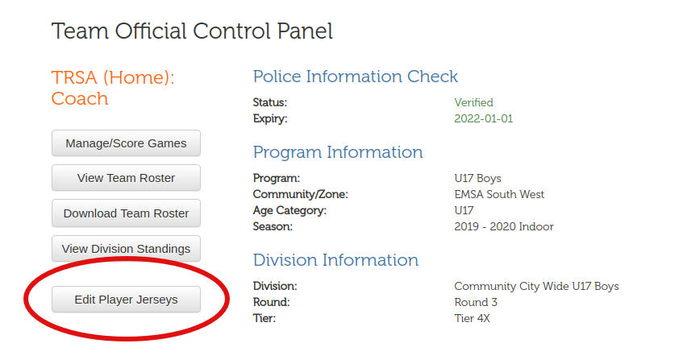
• Step 2: Fill in the “Jersey” field with a 1- or 2-digit number. Leading zeroes are preserved (e.g., 09 isn’t converted to 9). Leaving the field blank will remove the jersey number from the player. Repeat for the other players. Note that it’s possible to leave 1 or more players without jersey numbers; the U4s don’t need jersey numbers.
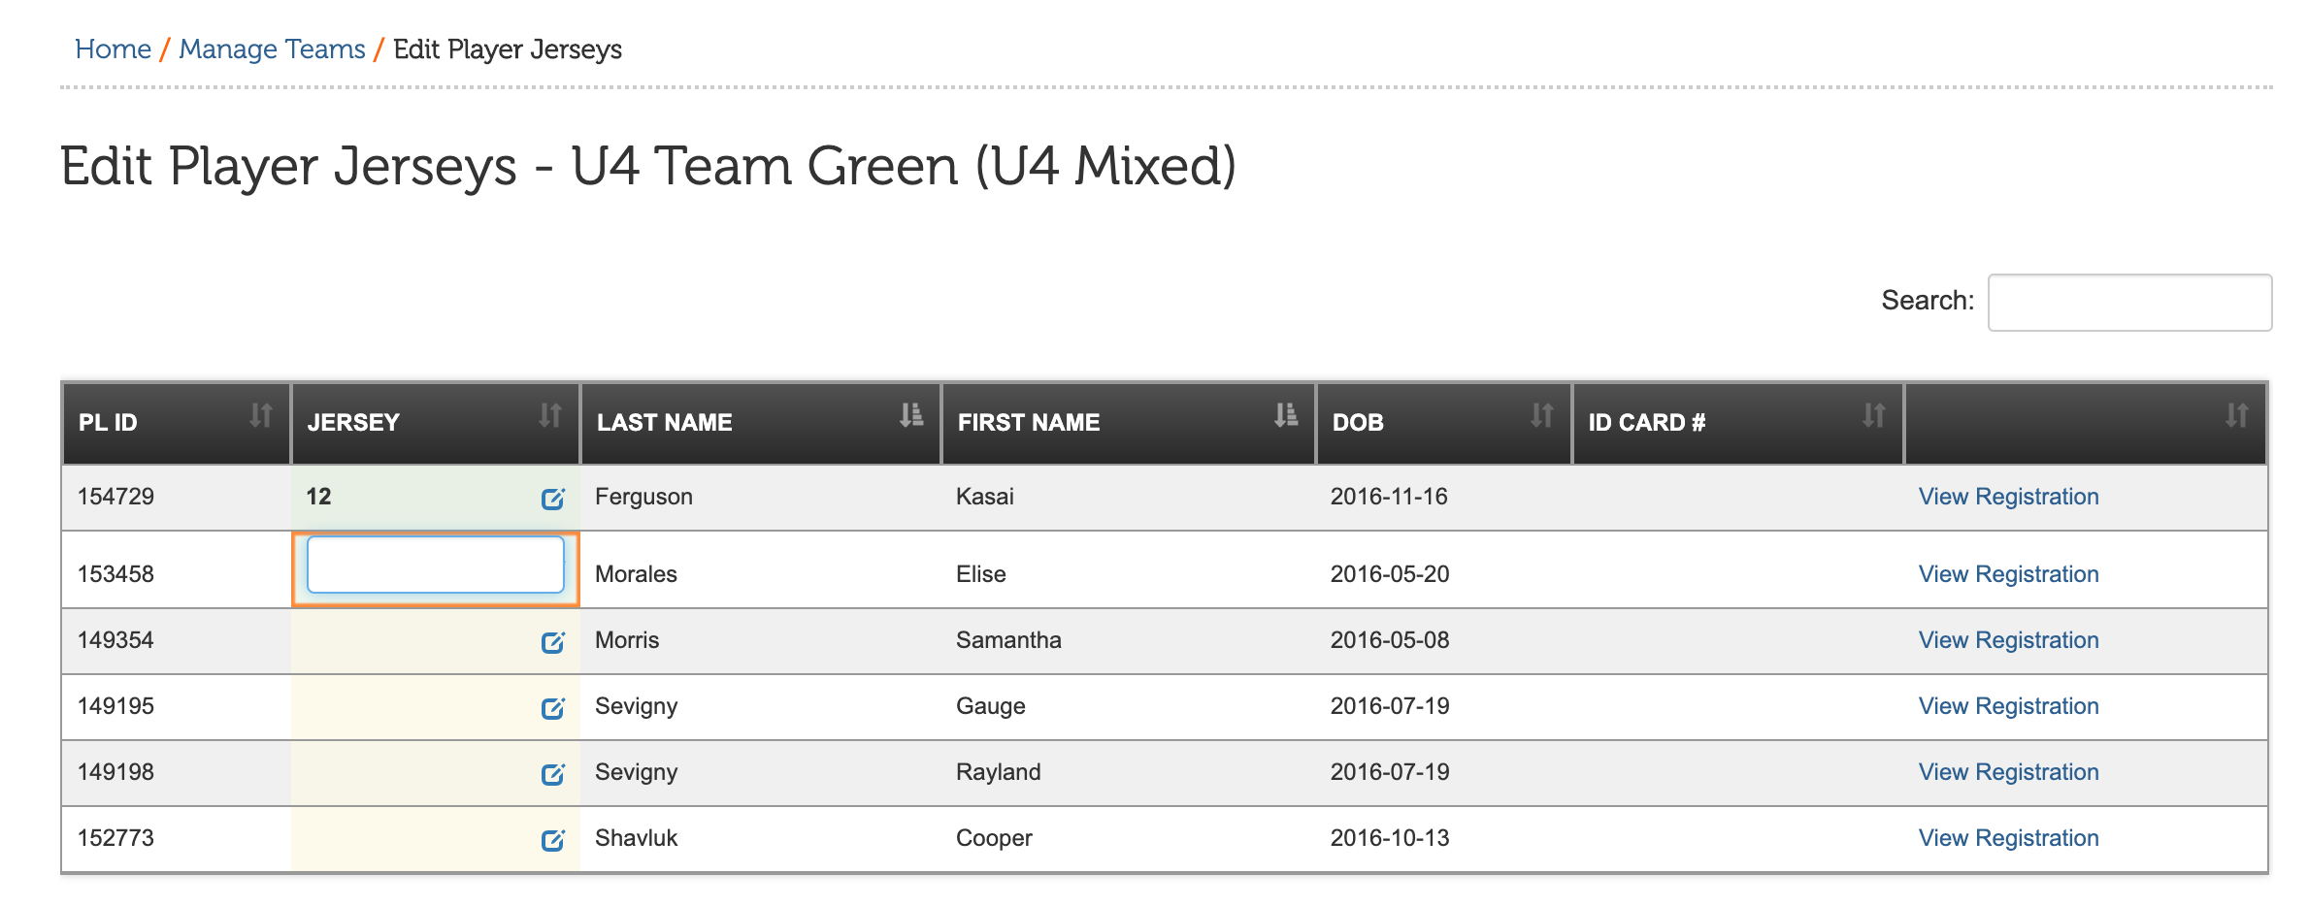
Once this has been completed, your player’s jersey numbers will now auto-populate on your electronic game sheets.
How To Print Electronic Game Sheets:
• Step 1: Log into the EMSA Portal and click on the “Manage/Score Games” button in the Team Official Control Panel:
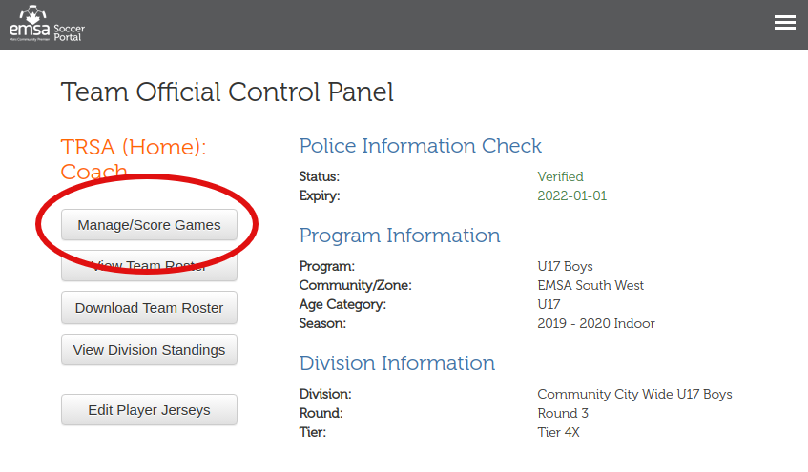
• Step 2: Find the game in the table and click the “Download” link under the “Game Sheet “column and the game sheet will automatically download.
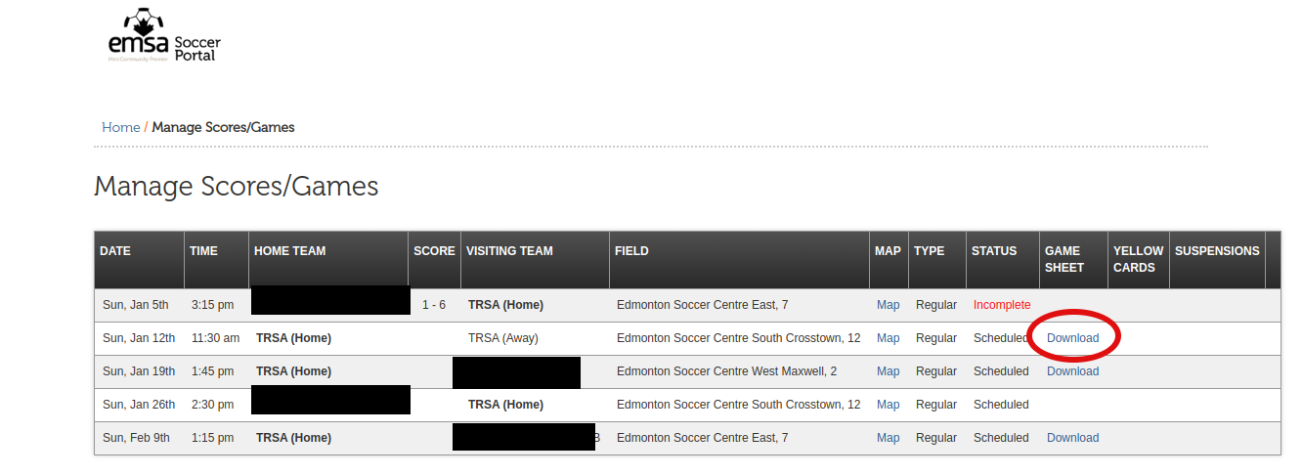

Field Closure Information
A complete list of field closure lines and websites can be found here:
https://emsamain.com/seasoninfo/outdoorseason/rain-out-lines/

Scoring Games on the EMSA Website
Registered coaches, assistant coaches and team managers are responsible for scoring the game results online. These persons must be registered on the team Portal roster in order to have access to the system. Please contact your zone office if you require access online.
Scoring the game online is the responsibility of the HOME TEAM. Game results must be input online by 1:00 PM the following day. Failure to do so will result in an administration fee being issued to the head coach of the HOME TEAM.

Instructions for Scoring Games
- Go to www.emsamain.com and click on the Coach Login link at the top of the page:
- Please sign in with your account.
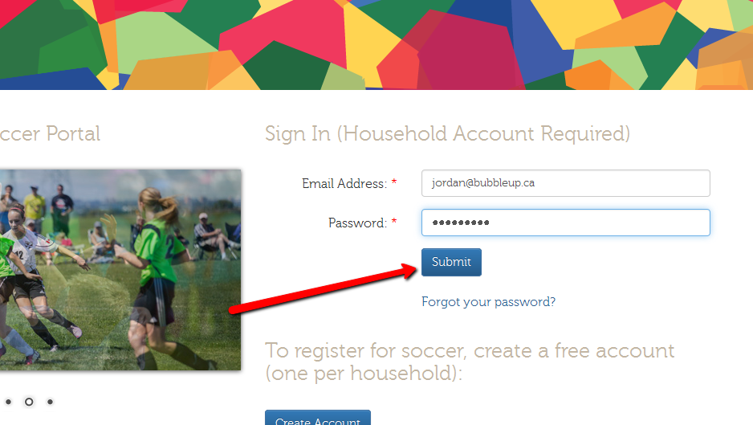

- Select the Team Official role for the team you are coaching. A person may have multiple team official roles (1 role per team). In this example, a McLeod coach with last name Johnson is signing in.
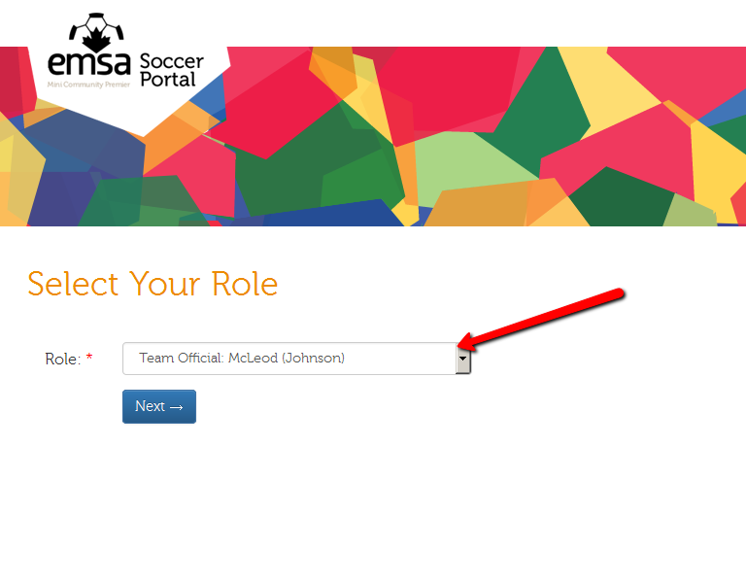

- Once signed in, you will be redirected to the Team Official Control Panel. Click the Manage Score/Games button.
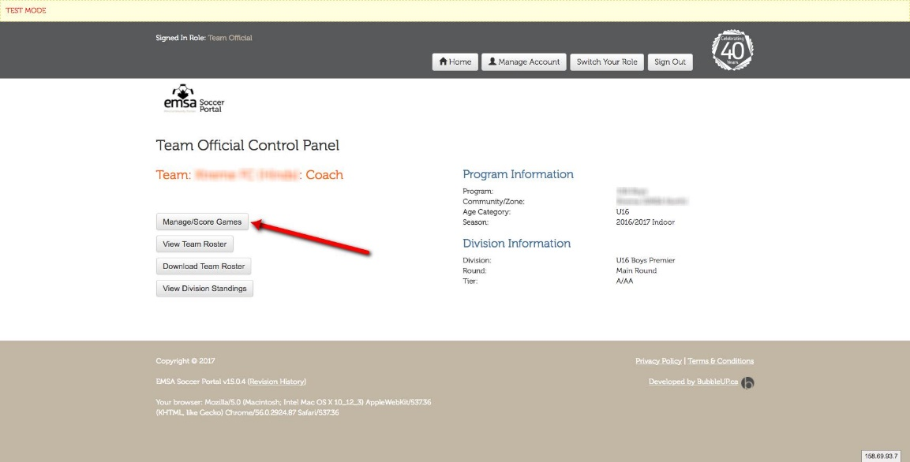
- On the Manage Scores/Games screen, you will see a list of all games for your team. Once a game is ready to have a score recorded, an edit pencil button will be available. Click the edit pencil button.
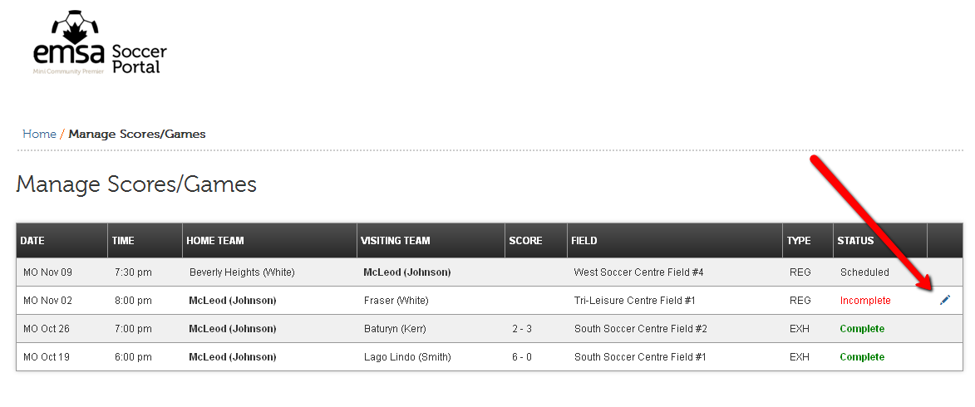

- On the Score Game form, complete the required fields by entering the home team score and the away team score.
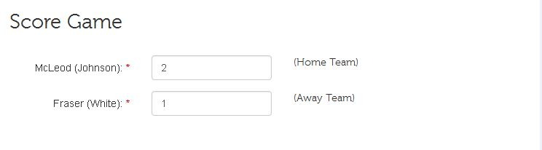

- Lastly, please submit feedback regarding the referee officiating of the game. There are 6 questions to be completed and an option to provide comments. This step is optional!

- Once the form is complete, click the Submit button.

- After submission, the game status will be changed to Under Review. An EMSA Administrator will review the game sheet and verify the information has been collected and acknowledged.
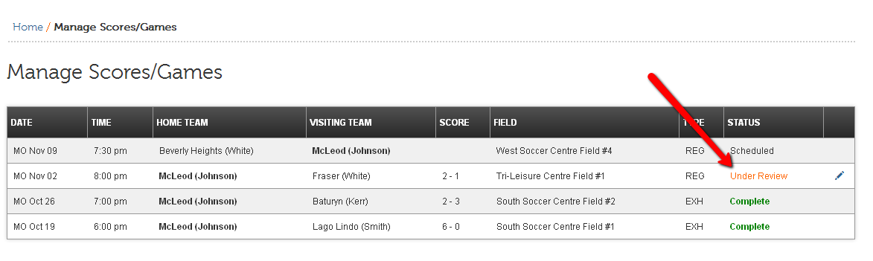
- If the Administrator verifies the game, the status will be marked as Complete. However, if there is an issue with an emailed/faxed game sheet, an email will be sent back to the coach asking for the game sheet. In this case, the status will be changed to Information Required.
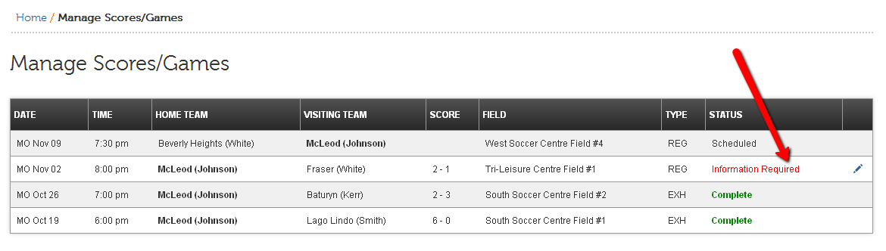

Submitting the Game Sheets to the EMSA Office
- Home team is responsible for submitting BOTH team’s game sheets, along with any trialist or permission forms for BOTH teams.
• Option #1 Scanned PDF/JPEG
Use a scanner to scan the game sheet into a PDF or JPEG format and email to:
Community Game Sheets communitygamesheets@gmail.com
Club Game Sheets: angelad@emsamain.com
• Option #2 Photo Taken by Phone
You may also choose to take a high quality photograph of the game sheet, and email or text the JPEG version of the photo to:
Community Game Sheets: communitygamesheets@gmail.com OR TEXT TO 780-413-3672
Club Game Sheets: angelad@emsamain.com OR TEXT TO 587-334-2949

Please ensure the entire game sheet is visible in the photo and get as close to the game sheet as possible without cutting any sides/edges off in the photo. If the image quality is poor or the entire game sheet is not visible, an EMSA Administrator will request a new version to be sent. Please ensure there is only one document in each photo. Do not send photos with multiple game sheets or trialist forms in the one photo.

Game Sheet and Game Score Admin Fees
Issue | Result
Team does not supply game sheet (either electronic download or completed handwritten blank one) | Default game & $100.00 admin fee
Incomplete Game Sheet (missing information) | $50.00 admin fee
Game Sheets Not Submitted by 1pm the day after the game | $50.00 admin fee
Game Not Scored in EMSA Portal by 1pm the day after the game | $75.00 admin fee

Correspondence Liaison
Coaches, assistant coaches, managers and the referee liaison (when applicable) are the acting correspondence liaison for their team.
Any and all communication between the EMSA main office and individual teams will be done through the teams’ correspondence liaisons only. These are the only individuals who will have the authority to contact the EMSA main office via phone and/or email. Communication to the office outside of the correspondence liaisons will not be addressed.
All communication from the EMSA main office to the correspondence liaison will be sent via email to the team officials that are officially registered on the team’s Portal Roster. It is the teams’ responsibility to ensure that they are checking their email regularly for information from the EMSA main office. It is the correspondence liaisons responsibility to ensure that the EMSA main office has the most up-to-date email information. Please ensure that the EMSA main office is given an alternate email address, should you be unavailable for a period of time.
Referee Liaison Program
The abuse of game officials by coaches and spectators is the main reason why referees (especially those in their early teens) drop out of the development program. As a result, we face severe shortages of game officials at all levels. Addressing this unacceptable behavior is a top priority for EMSA, particularly if minor soccer is to have an adequate supply of referees.
Both Home and Away teams, participating in the U13-U19 community and U9-U19 club programs, are required to provide a referee liaison for every EMSA league game. The referee liaison can be any person over the age of 18, with the exception of the teams registered coach or assistant coach. The referee liaison can be a different person each game and their name must be PRINTED on the game sheet in the space provided. The referee liaison must wear an identifying neck lanyard and sit in a visible area in the stands with the spectators.
The referee liaison must be an individual who is willing and able to control and monitor the behavior of the parents and coaches throughout the game. This role is to be taken very seriously and the goal of this role is to keep the parents and coaches in the game following the rules as set forth in the code of conduct as well as maintaining respect for the referees and opposing team. This role is not in place for the referee liaison to question any calls made by the refs.
Description of Duties
- Wear the referee liaison neck lanyard – this is to be provided by a team official.
- Place yourself in the middle of your team’s spectators.
- Monitor the behavior of your team’s spectators and coaching staff.
- Quickly diffuse potential issues before they escalate by either making your presence more visible, or calmly addressing the behavior with the person(s) involved.
- Address inappropriate comments, gestures, and/or any other unsporting behavior directed at the game officials, players, coaching staff or any other individual by your team’s spectators.
- Submit a brief report in writing, outlining any incidents involving any individuals, to the referee after the game or to the EMSA office.
Failure to provide a referee liaison will result in a default win for the opposing team. All teams are granted a 15 minute grace period to provide a referee liaison.
Harassment
EMSA has zero tolerance for any form of harassment, bullying, discrimination or intimidation. Any EMSA player, team official, game official, parent or other participant who engages in such behaviour towards another EMSA player, team official, game official, parent or other participant will be subject to discipline by the EMSA Discipline Committee.

Players Registered and Dressed
Teams are limited to a maximum number of players permitted to be registered & dressed at one time during the season, according to the following:
- U9 and U11 16 players
- U13 – U19 20 players
**Teams are permitted to dress and play additional players only if they have received special dispensation from the EMSA Board of Directors.
Injured players who are not playing are permitted to be in the technical area with their team permitted the following conditions are met:
- Player is dressed in a team jersey with number.
- Their name is written down on the game sheet along with jersey number and I.D. card number.
- “INJ” or “injured” should be written beside their name on the game sheet.
- They must present their I.D. card (or electronic copy) to the referee prior to the start of the game.
Guest Players/Trialists
A form must be filled out and submitted to the referee with your game sheet prior to game start for each game (or prior to the start of the second half if the trialist arrives late). If you are using the same trialist for multiple games you must have copies of the trialist form to submit to the referee at each game. Please ensure you review the complete trialist/guest player regulations in the full EMSA Rule and Regulations book. Using an illegal trialist will result in a game forfeiture. If there is any question whether a trialist may be legal or not, please ensure you contact the EMSA office for verification prior to using the trialist.
• Trialists do not require player cards.
• Prior written approval of the Coach or Team Designate of the team for which the player is registered must be obtained. The written approval (trialist form) must be surrendered to the referee at the start of the game or prior to the start of the second half if the trialist arrives late. It must be submitted along with the game sheet to the EMSA office.
• For regular league play, any registered player may play in a higher Tier (in the same age category) or higher age category. You cannot use lateral trialists (same age group/same tier). If divisions (tiers) and/or age groups are combined, you cannot use trialists from teams playing in the same combined group as your team.
• The player must already be registered on another EMSA team during the current season. If they are not registered on any EMSA team during the current season then they cannot be used as a trialist with the exception of rule 4.8(4)e.
• Players who are playing up an age group are not permitted to be a trialist for a team that is in a lower age category then the current team they are registered on even if their birth year is the same as the lower age group.
• No EMSA player may play on an EIYSA team as a trialist for league games. No EIYSA player shall play on an EMSA team as a trialist for league games.
• Teams from out of district who are participating in the EMSA program are permitted to use trialists from their parent organizations/zone/district as long as they are an ASA registered player for that season; they are from a lower division or lower age category; and the use of the trialists does not violate any EMSA or ASA rules.
• Club players are ineligible as trialists on all community teams.
• Players who are currently serving a suspension from EMSA or ASA are ineligible as trialists.
• You can list multiple players on one trialist form if they are coming from the same team.

The following conditions must also be met which are specific to Club or Community teams:

CLUB TEAM SPECIFIC TRIALIST RULES (applies to Club teams only):
• CLUB Trialists must be from the same EMSA Boundary (South or North).
• No more than a total of five (5) such players can be recruited for any one (1) game. Club teams may use trialists to increase their game roster size up to the maximum team roster size set out in Rule 4.4.
• A player can be used a trialist for an unlimited amount of league games. The trialist must be noted on your game sheet in the provided trialist space prior to the game start when the game sheet is given to the referee.

COMMUNITY TEAM SPECIFIC TRIALIST RULES (applies to Community teams only):
• Community Trialists must be from the same Zone.
• No more than a total of three (3) such players can be recruited for any one (1) game. Trialist players cannot be used to increase the roster size for a game greater than the team’s current registered roster size (you can only use trialists to replace players that are missing).
• A player can be used a trialist for a maximum of five (5) games per team (tournament & exhibition games do not count towards the total number of games). The trialist must be noted on your game sheet in the provided space prior to the game start when the game sheet is given to the referee.

*Trialists are NOT permitted in Provincial Competitions. If additional players are needed for Provincials, they must be duly registered prior to the Player Transfer Deadline for your tier.
Trialist Form – download at: https://emsamain.com/wp-content/uploads/2022/02/Trialist-Form.pdf

EMSA Electronic I.D. Cards/EMSA I.D. Cards (Players/Team Officials)
The following EMSA divisions require an EMSA I.D. Card or EMSA E-card:
For Players:
Age Group | Community | Club
U9
U11
U13
U15
U17
U19

- Electronic EMSA I.D. cards/EMSA ID cards must be presented to the referee prior to game kickoff.
- No other forms of identification will be accepted.
- Players must present themselves to the referee while the cards are being shown so the ref can compare the picture to the player and cross reference the number on the game sheet.
- Electronic EMSA I.D. cards/EMSA ID cards are to be made available to the opposing team officials or the EMSA League Director, if requested.
- Should a player be without their card/e-card at kickoff, they may play the game provided that their card/e-card is presented to the game official prior to end of the game. Failure to present the players card/e-card to the game official prior to the end of the game, will result in a default loss for the team. The player and team will also be subject to further disciplinary action being taken by the EMSA Discipline Committee.
- Players that do not require an EMSA I.D. card/e-card that are participating as a trialist player in a division/age group which does, are not required to get one. These players will simply need to provide the completed trialist form to the game official, prior to kickoff. This form will be kept with the game sheet and submitted to the League Director at the EMSA office.
- Out of District Non EMSA Member players are permitted to use their own youth District I.D. cards in place of electronic EMSA cards as long as their District has received permission from the EMSA office
For Team Officials (head coaches, assistant coaches and managers):
Age Group | Community | Club
U9
U11
U13
U15
U17
U19

- Coaches, assistant coaches and managers registered to teams in age categories/divisions where EMSA I.D. cards/e-cards are required, must present their card/e-card to the game official prior to kickoff for verification.
- No other forms of identification will be accepted.
- Team Officials who are unable to present their card/e-card at the start of the game will not be permitted in the technical area and must sit with the spectators, away from the technical area. If no team officials are able to produce their card/e-card, the game will be recorded as a default loss and three (3) points and five (5) goals will be awarded to the opposing team.
- If a team knows ahead of time that it will be unable to supply the EMSA I.D. cards/e-cards for the registered team officials, or if the registered team officials are unable to attend a game, the team may request that a substitute coach or coaches be granted permission to take control of the team temporarily. A request to allow for a substitute coach or coaches must be sent to the EMSA League Director and should the request be approved; they will provide a permission letter to allow the substitute coach/coaches on the bench. This permission letter must be handed to the referee prior to kickoff and will be kept for submission to the EMSA League Director along with the master game sheet.
- Team officials CANNOT be written on the bench attendant line if they are unable to produce their electronic ID card.
- If a team official participates in a game without their card/e-card being shown to the ref, then the team will default the game and that team official will be suspended for one game.
- Out of District Non EMSA Member team officials are permitted to use their own youth District I.D. cards in place of EMSA cards as long as their District has received permission from the EMSA office.

How to Download Your Team’s Electronic EMSA I.D. Cards
You can find the link to download the electronic list or print the cards on paper by logging into the EMSA Portal. Ensure your “role” is selected as “team official” and then click on “Download Team ID Cards”, see below. Note: only team officials who are listed on the EMSA Portal Roster will be able to log in and see this info. Please note that if your Club/District uses their own I.D. cards instead of EMSA I.D. cards this feature will not be available to you.
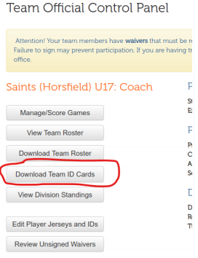

Team Officials in the Technical Area
- Regular season league play permits a maximum of five (5) team officials in the technical area, one of which must be of the same gender as the team’s players.
- All Team officials (coach, assistant coach and manager) must produce an EMSA I.D. card/e-card to be permitted in the technical area. If you cannot produce an electronic EMSA I.D. card prior to the start of the game you will not be permitted in the technical area and you must sit with the spectators for the duration of the game. No other forms of I.D. will be accepted.
- Team officials must remain within their technical area around the bench and are not permitted to walk up and down the length of the field to coach.
- Team Officials who cannot produce their I.D. card/e-card are NOT PERMITTED to be put on the game sheet under the bench attendant section instead. As a team official you MUST have your card/e-card. There are NO exceptions to this and NO other forms of I.D. are accepted for team officials.
- Out of District – Non EMSA Member team officials are permitted to use their own youth District I.D. cards in place of EMSA cards as long as their District has received permission from the EMSA office.

Bench Attendants in the Technical Area
• If you have a team official on the bench and listed on the game sheet that is the same gender as the team, then it is not mandatory that you have a bench attendant. You can still have a bench attendant if you wish to help out but they can be any gender.
• If you do not have a team official on the bench that is the same gender as the team, then it is mandatory that you have a bench attendant that is the same gender as the team.
• In situations where females play or trialist on boys’ teams the team must include at least one female team official or bench attendant on the bench.
• Bench attendants must be at least 18 years of age.
• One bench attendant per game is permitted.
• At no time can a registered team official on your team (coach, assistant coach or manager) be written down on the bench attendant line of your game sheet. If a person is a registered team official that appears on your EMSA Portal Roster, then they must be marked down on one of the team official lines. The bench attendant line is only for those individuals helping out who are NOT on the roster.
• If a team official forgets their I.D. card (or electronic copy), they cannot be marked down as a bench attendant instead. They must sit in the stands for the entire game.
• The bench attendant is included in the 5 maximum non–playing personnel on the bench. This means if you are using a bench attendant, then you can only have four (4) other team officials on the bench as the bench attendant would be the 5th.
• Bench attendants do not need an EMSA or District I.D. card, but they have to show a form of government issued photo I.D. to the referee to prove their identity for those divisions that require I.D. cards.
• If the bench attendant is removed from the game by the referee due to misconduct, the head coach or the bench attendant will serve any suspension issued.
• It is recommended that the bench attendant attend to any injured player on the field, however any team official (regardless of gender) is permitted to assist the injured player once given permission to enter the field from the referee.
Technical Trainers in the Technical Area
- Teams are permitted to have one technical trainer per game in the technical area/on bench.
- The technical trainer will be included in the maximum of five (5) team officials permitted in the technical area/on bench.
- The technical trainer must have a special printed yellow plastic card from the EMSA office which is shown to the ref.
- The technical trainer’s name and card number must be written on the game sheet in the team official’s section.
- The technical trainer must have the word “TECH” or “TT” written down beside their name on the game sheet.
- The technical trainer is permitted to take over the team if there are no other team officials present.
- Technical trainers cannot be listed on the bench attendant line.
- The Technical Trainer must be noted on an approved list kept by the EMSA Main office in order to participate in any games.
- Any cautions or red cards issued to the Technical Trainers will result in the same Discipline dispensed to the Team Officials.

Equipment, Casts, Splints and Jewelry
- Cleated outdoor soccer shoes, or runners, are the only permissible footwear to be worn by players.
- It is at the discretion of the game official what will constitute dangerous equipment which must be removed in order for play to be allowed. Game official has final say.
- Under no circumstance will splints and/or casts be permitted to be worn on the field during game play.
- Players who wear braces (knee, ankle, wrist etc…) will be permitted to wear these during game play provided that the brace does not have the potential to injure others. The decision to allow specific braces is left to the game official.
- Players refusing to remove any type of jewelry at the request of the referee, including all external body piercings, will not be permitted to play. Taping is not permitted.
It is the responsibility of the Home Team to supply two (2) game balls as specified below:

Age Group | Ball Size
U9 | Size 4
U11 | Size 4
U13 | Size 5
U15 | Size 5
U17 | Size 5
U19 | Size 5

- Corner Flags: Each team must provide three (3) flags that meet FIFA requirements are to be of a solid structure, distinctive in colour, and a minimum of five (5) feet high, with a minimum diameter of 1” and a maximum diameter of 2”. These flags are to be firmly planted in the ground at each corner of the field at the goal line and at the center line. If a team forgets their flags the referees should do their best to mark the corners of the field with a safe substitute.
- Goal Net: Each team must provide a goal net. If a goal net is not provided then then that team will default the game.
- It is the HOME team’s responsibility to change their jersey or wear pinnies should the jersey colour of both teams conflict.
- In the event that a team does not have uniform jerseys at the start of the game, the game will be defaulted, with three (3) points and five (5) goals being awarded to the opposing team.

Game Length & Time Outs & 2/3 Marks
Age | Total Time | Regulation Halves | 2/3 Game Time
U15, U17, U19 | 90 minutes | 2 X 45 minutes | 60 min
U13 | 80 minutes | 2 X 40 minutes | 53.33 min
U11 | 70 minutes | 2 X 35 minutes | 46.66 min
U9 | 60 minutes | 2 X 30 minutes | 40 min

- Each team is entitled to up to three (3) minutes of interval time per the referee’s discretion.
- There are no time outs permitted in the Outdoor Season.
- If 2/3 of the game time has been played, the game will be considered legal should it be called by the referee for any reason.
- Please also note the 2/3 rule also comes into play with whatever length of the game has been agreed upon by team officials and referees. For example, for a U17 game (2 x 45 minute halves) if the weather is cold or stormy and the coaches and referees agree prior to the start of the game that they are only going to play two 35 minute halves instead of the two 45’s, the 2/3 game time mark would be for the two 35 minute halves.
Late Arrivals and Failure to Show
- A team will not be considered as ‘present’ at the scheduled kickoff time without a minimum of:
U13/U15/U17/U19 seven (7) registered players
U11 six (6) registered players
U9 five (5) registered players
- A 15-minute grace period is provided for a team to be present. If a team is not present after such time, the game will be recorded as a default win for the opposing team and they will be awarded three (3) points and five (5) goals in their favor by the league director.
- In order to claim the default win, the team that is present must turn in their completed game sheet to the referee for him to sign off on. He will then return it to the team to be sent to the EMSA office.
- Late players must arrive prior to kickoff of the second off. Players arriving after such time will not be permitted to play.
- It is not mandatory for the opposing team to wait any longer than the 15-minute grace period. After this time has expired, the field may be used for a practice or an exhibition game for the remainder of the time that was scheduled for the game.
- In the event that both teams are not present, the game will be recorded as ‘cancelled’. These games will not be rescheduled.
- An administration fee will be issued to the head coach of the team who fails to show up to their scheduled game, provided they did not notify the EMSA league director 48 hours prior to the game.

Forfeits of Games After EMSA Office Hours
If you are aware that you will be forfeiting your league game ahead of kick off time and you are not able to reach the EMSA League Director to get verification that the forfeit message was received (you will receive an email back if it was received in time) OR if it is after office hours on game day the following procedure must be followed:
- Team officials forfeiting must email the team officials of the opposing team and CC the EMSA League Director to let them know they will not be coming to the game.
- Team forfeiting must also call the team officials of the opposing team on the phone to let them know they will not be coming to the game. Try all team officials’ numbers on the contact list and leave messages if necessary.
- If the opposing team wishes to claim the forfeit win, they must send one (1) carded team official to the field of play to meet the referees and have the referees sign off on the game sheet. The entire team does not need to show if you have received an email from the other team declaring a forfeit, just one team official only.

If the opposing team fails to send one team official to the field to have the game sheet signed off on, the game will be cancelled, not rescheduled and no points or stats will be awarded to either team.

*Note: this is only in the case the forfeit message is not received by the EMSA League Director in time to cancel the game (no response/reply). If the League Director receives and verifies the notice of forfeit, they will send an email out to both teams and the referees cancelling the game and then you do not have to send a team official to the field.

General Reschedule Requests: Community League (Tier 4 and lower)
If a regular league game conflicts with a SOCCER TOURNAMENT, GRADUATION or FINAL EXAMS the game may be rescheduled. A soccer tournament, graduation or final exams are the only three reasons accepted for rescheduling games. NO OTHER REASONS will be accepted and games will stay as scheduled. For tournament reschedules, you are limited to requesting a maximum of 2 tournaments per season. If you have to travel for your tournament outside of the Province but inside Canada, an allowance of one day prior and one day after the tournament is allowed. For International tournaments, total of 10 days (travel and tournament dates, inclusive) will be allowed.
*NOTE: All rescheduling requests be received by the EMSA office ONE WEEK PRIOR to the original game date.
Steps for Rescheduling a Game:
Step #1: If you are the team who is requesting the reschedule, you must send an email to the EMSA Community League Director, jennad@emsamain.com, indicating the game details and reasoning for the reschedule request.
Step #2: BOTH teams involved will then receive an email from the League Director indicating that permission has been given to reschedule the game. If you don’t receive that permission email it means the game has not been given the go ahead to be rescheduled and will remain as originally scheduled.
Step #3: The EMSA League Director will email the Home Team’s Zone Referee and Field Assignor to cancel the originally scheduled game.
Step #4: The TEAM WHO REQUESTED THE RESCHEDULE contacts the opposing coach to come up with an agreed upon rescheduled date. The opposing team officials have 48 hours to respond and work out a new date. If the new date is not worked out within 48 hours then the EMSA League Director reserves the right to automatically reschedule the game to a date chosen by the EMSA office.
Step #5: Once a date has been agreed upon, the TEAM WHO REQUESTED THE RESCHEDULE is responsible for emailing the EMSA League Director to notify of the new date and time. The EMSA League Director will then assign a field. **If you are an Out of Edmonton District team, you will need to contact your District Field Assignor first for a field as the EMSA Office does not take care of your area’s fields. You will need to send the EMSA League Director an email once you have the new field confirmed.
Step #6: League Director will update the website with the rescheduled game details and the Portal will automatically generate an email to both teams and the Referee Assignor. The rescheduled game is not considered legal until that time. Please keep in mind that the EMSA office is only open during the weekdays.
If the opposing coach and you cannot agree on a reschedule date, please notify the League Director and he/she will step in and take over the rescheduling process. Please note that you must give the League Director enough notice to be able to help you with the rescheduled game. If you send notice a day or two before the rescheduling deadline then we will be unable to help you.
*Once the game has been confirmed by the League Director, if one team fails to show for a rescheduled game then that team will lose by default. If both teams fail to show for a rescheduled game, the game will go down as not being played, no stats or points will be awarded and the game will not be rescheduled.
ALL RESCHEDULED GAMES MUST BE COMPLETED within 3 weeks of the original scheduled date. If there is less than 3 weeks left on the schedule you must have those games completed prior to your last game on the schedule. If the game does not get played within the 3 week deadline or before the last game on the schedule (if there are less than three weeks left) then it will go down as not being played, no stats or points will be awarded. However, if the outstanding game will impact the standings in regards to post season play advancement in the main/final round, the EMSA League Director will reschedule the game. If you are rescheduling the last game on your schedule, it must be rescheduled to a date prior to when it was originally scheduled.
General Reschedule Requests: Club League

If a regular league game conflicts with a SOCCER TOURNAMENT, GRADUATION or FINAL EXAMS the game may be rescheduled. A soccer tournament, graduation or final exams are the only three reasons accepted for rescheduling games. NO OTHER REASONS will be accepted and games will stay as scheduled. For tournament reschedules, you are limited to requesting a maximum of 2 tournaments per season. If you have to travel for your tournament outside of the Province but inside Canada, an allowance of one day prior and one day after the tournament is allowed. For International tournaments, total of 10 days (travel and tournament dates, inclusive) will be allowed.

*NOTE: We ask that all rescheduling requests be received by the EMSA office ONE WEEK PRIOR to the original game date.

Steps for Rescheduling a Game:

Step #1: If you are the team who is requesting the reschedule, you must send an email to the EMSA League Director, angelad@emsamain.com, indicating the game details and reasoning for the reschedule request.

Step #2: BOTH teams involved will then receive an email from the League Director indicating that permission has been given to reschedule the game. If you don’t receive that permission email it means the game has not been given the go ahead to be rescheduled and will remain as originally scheduled.

Step #3: The EMSA League Director will email the Home Team’s Zone Referee and Field Assignor to cancel the originally scheduled game.

Step #4: The TEAM WHO REQUESTED THE RESCHEDULE contacts the opposing coach to come up with an agreed upon rescheduled date. The opposing team officials have 48 hours to respond and work out a new date. If the new date is not worked out within 48 hours then the EMSA League Director reserves the right to automatically reschedule the game to a date chosen by the EMSA office.

Step #5: Once a date has been agreed upon, the TEAM WHO REQUESTED THE RESCHEDULE is responsible for emailing the EMSA League Director to notify of the new date and time. The EMSA League Director will then assign a field. **If you are an Out of Edmonton District team, you will need to contact your District Field Assignor first for a field as the EMSA Office does not take care of your area’s fields. You will need to send the EMSA League Director an email once you have the new field confirmed.

Step #6: League Director will update the website with the rescheduled game details and the Portal will automatically generate an email to both teams and the Referee Assignor. The rescheduled game is not considered legal until that time. Please keep in mind that the EMSA office is only open during the weekdays.

If the opposing coach and you cannot agree on a reschedule date, please notify the League Director and he/she will step in and take over the rescheduling process. Please note that you must give the League Director enough notice to be able to help you with the rescheduled game. If you send notice a day or two before the rescheduling deadline then we will be unable to help you.

*Once the game has been confirmed by the League Director, if one team fails to show for a rescheduled game then that team will lose by default. If both teams fail to show for a rescheduled game, the game will go down as not being played, no stats or points will be awarded and the game will not be rescheduled.

ALL RESCHEDULED GAMES MUST BE COMPLETED within three (3) weeks of the original scheduled date. If there is less than three weeks left on the schedule you must have those games completed prior to your last game on the schedule. If the game does not get played within the three week deadline or before the last game on the schedule (if there are less than three weeks left) then it will go down as not being played, no stats or points will be awarded. However, if the outstanding game will impact the standings in regards to post season play advancement in the main/final round, the EMSA League Director will reschedule the game. If you are rescheduling the last game on your schedule it must be rescheduled to a date prior to when it was originally scheduled.

CSA Lightning and Severe Weather Policy

When thunder roars, go indoors!
The safety of players, coaches, management and spectators is the primary concern in any weather event that occurs during all matches sanctioned by Canada Soccer. By understanding and following the below information, the safety of everyone shall be greatly increased. Ultimately, the referee has the final say over delaying or restarting a match due to weather. Waiting to stop play or not waiting to start play may result in a serious injury or loss of life. Referees are expected to act responsibly when dealing with such events during matches they are controlling
If you can hear thunder, you can get hit by lightning. As soon as you hear thunder, quickly get to a safe location. More people are struck before and after a thunderstorm than during one. Stay inside for 30 minutes after the last rumble of thunder.
Additional Information
Please note the following recommendations from Environment Canada:
• To plan for a safe day, check the weather forecast first. If thunderstorms are forecast, avoid being outdoors at that time or make an alternate plan. Identify safe places and determine how long it will take you to reach them.
• Watch the skies for developing thunderstorms and listen for thunder. As soon as you hear thunder, quickly get to a safe location. If you can hear thunder, you are in danger of being hit by lightning. More people are struck before and after a thunderstorm than during one.
• Get to a safe place. A safe location is a fully enclosed building with wiring and plumbing. Sheds, picnic shelters, tents or covered porches do NOT protect you from lightning. If no sturdy building is close by, get into a metal-roofed vehicle and close all the windows.
• Do not handle electrical equipment, telephones or plumbing. These are all electrical conductors. Using a computer or wired video game system, taking a bath or touching a metal window frame all put you at risk of being struck by lightning. Use battery-operated appliances only.
• If caught outdoors far from shelter, stay away from tall objects. This includes trees, poles, wires and fences. Take shelter in a low-lying area but be on the alert for possible flooding.
Be aware of how close lightning is occurring. Thunder always accompanies lightning, even though its audible range can be diminished due to background noise in the immediate environment and its distance from the observer.
When larger groups are involved, the time needed to properly evacuate an area increases. As time requirements change, the distance at which lightning is noted and considered a threat to move into the area must be increased.
Know where the closest “safe structure or location” is to the field or playing area and know how long it takes to get to that safe structure or location. Safe structure or location is defined as:
Any building normally occupied or frequently used by people, i.e., a building with plumbing and /or electrical wiring that acts to electrically ground the structure. Avoid using shower facilities for safe shelter and do not use the showers or plumbing facilities during a thunderstorm.
In the absence of a sturdy, frequently inhabited building, any vehicle with a hard metal roof (not a convertible or golf cart) and rolled-up windows can provide a measure of safety. A vehicle is certainly better than remaining outdoors. It is not the rubber tires that make a vehicle a safe shelter, but the hard metal roof which dissipates the lightning strike around the vehicle. Do not touch the sides of any vehicle!
If no safe structure or location is within a reasonable distance, find a thick grove of small trees surrounded by taller trees or a dry ditch. Assume a crouched position on the ground with only the balls of the feet touching the ground, wrap your arms around your knees and lower your head. Minimize contact with the ground because lightning current often enters a victim through the ground rather than by a direct overhead strike. Minimize your body’s surface area and the ground! Do not lie flat! If unable to reach safe shelter, stay away from the tallest trees or objects such as light poles or flag poles), metal objects (such as fences or bleachers), individual trees, standing pools of water, and open fields. Avoid being the highest object in a field. Do not take shelter under a single, tall tree.
Avoid using the telephone, except in emergency situations. People have been struck by lightning while using a land-line telephone. A cellular phone or a portable remote phone is a safe alternative to land-line phones, if the person and the antenna are located within a safe structure or location, and if all other precautions are followed.
When considering resumption of any athletics activity, wait at least thirty (30) minutes after the last flash of lightning or sound of thunder before returning to the field.
First aid for lightning victims
Prompt, aggressive CPR has been highly effective for the survival of victims of lightning strikes.
• Lightning victims do not carry an electrical charge and can be safely handled.
• Call for help. Victims may be suffering from burns or shock and should receive medical attention immediately. Call 9-1-1 or your local ambulance service.
• Give first aid. If breathing has stopped, administer cardio-pulmonary resuscitation (CPR). Use an automatic external defibrillator if one is available.
For additional information the following websites are helpful: http://www.ec.gc.ca/foudre-lightning/default.asp?lang=En&n=57412D67-1 www.weatheroffice.gc.ca/lightning
Alberta Soccer Air Quality Procedure

AIR AWARE – AIR QUALITY MONITORING GUIDELINES
This document is meant to serve as a guideline for Affiliated Members, Team Officials, Players and Match Officials affiliated with Alberta Soccer. As a guideline, it suggests what Affiliated Members, match officials and team officials should consider in assessing air quality at local fields and awareness of potential health impacts.

BASIS
The best scientific information available is used for these guidelines. It will be updated as new knowledge becomes available. This guideline document includes background information about the Air Quality Health Index (AQHI), asthma management, and exercise- induced bronchoconstriction (EIB).

POLICY
- Go to http://environment.alberta.ca/apps/aqhi/aqhi.aspx (APP also available)
  - Use the Alberta website. The Environment Canada (federal) website does not list St. Albert and Strathcona County stations. This is important because Edmonton, St. Albert, and Strathcona County (Sherwood Park) can have different index ratings even though they are in proximity.
- Click on the AQHI station name
  - This brings up a pop-up box with the AQHI for that station. See the example on next page.
- Note the station, time, and date, and Index calculation.
  - Updates usually occur hourly (at the top of the hour).
  - Use the index calculation that is within one hour of scheduled kick-off or practice time.
  - If the AQHI is “7” or higher then go to steps 4 or 5 as appropriate

- Games
  - If the Affiliated Member has not cancelled games in advance all teams and match officials should arrive ready to play.
  - If the AQHI is still above “7” at the next calculation the teams involved and the match official should consider delaying kick-off or cancelling the game.
    - The match official reserves the final right to cancel the game if the conditions
are considered dangerous, in the match official’s opinion.

ii. Referee to write on game sheet reason for abandonment with the Index calculation, time & date number calculated and AQHI station used.
c. If air quality changes dramatically during a game (e.g. sudden smoke event caused by wind direction change) referees and team officials are advised to use their discretion. Record all decisions and relevant information on the game sheet.

- For Practices
  - Team officials should consider a rescheduled practice or postponing practice until a later time.

Incorporating
- Incorporating AQHI into your training practices
  - Access the latest AQHI calculations
    - If air quality is “3” or below continue with training as normal.
    - If air quality is an index of 4 – 6 then be prepared to adjust the practice by:
      - Reducing the intensity.
      - Reducing the duration of the practice.
      - Providing resting periods.
    - If air quality is “7” or above reschedule.
- Be aware of weather and other conditions:
  - Current forest fires and their locations in the province.
  - Local burning of stubble on fields or agricultural fields – these can increase particulate matter in the air without impacting the AQHI for a city.
  - Sudden and dramatic changes in wind strength and direction.
  - Proximity of any major road or highway.
  - Near or downwind of any industrial areas or other significant emission sources.
- Alberta Health Services maintains an Air Quality Advisory website. This site is helpful for planning your outdoor event. http://www.albertahealthservices.ca/news/air.aspx
EXAMPLE http://environment.alberta.ca/apps/aqhi/aqhi.aspx

BACKGROUND INFORMATION
- The AQHI is a web-based, risk management tool which describes a local reading of air quality as it relates to human health. While the Index number for a location can rise into the triple digits (Fort McMurray in 2016 peaked at over “180”) anything over “7” is of primary concern.
- The AQHI is calculated differently for Alberta in two significant ways. First, in the rest of Canada, the AQHI only measures ground-level ozone, fine particulate matter (PM_{2.5}) and nitrogen dioxide. In addition to these three pollutants, Alberta is more comprehensive by also including sulphur dioxide, hydrogen sulphide, total reduced sulphur and carbon monoxide in its AQHI reporting. Second, for the rest of Canada the AQHI is calculated on a 3-hour rolling average and so is less responsive to dramatic changes in air quality.
- Health Canada recommends through the AQHI that for strenuous activities like soccer anything above an AQHI of 7 then one should reschedule the event.
- The AQHI treats anything above 10+ as “Very High” with health messages for the “general” and “at risk” populations to reschedule all outdoor activities – strenuous or not.
- Elite athletes are in the “at-risk population because of the intensity and duration of exposure to outdoor air quality.” Women appear to be more affected than men due to smaller airways, lungs, and respiratory systems.
- Regarding air quality, soccer is considered a high exposure sport.
- Individuals tend to rely on sensory perception to evaluate air quality when, in fact, the
pollutants that present the greatest harm to human health are difficult to see or smell (e.g. ground level ozone).
- It is neither possible nor desirable to acclimatize athletes to air pollution. The US Olympic Committee recommends that when competing in high pollution areas the best strategy for training is alternative sites. “Stay away from air pollution.”
- Exercise-Induced Bronchospasm (EIB) is a sudden narrowing of the airways in response to vigorous exercise. It may occur in some individuals who have no pre-existing diagnosis of asthma. Most obvious symptoms of EIB include wheezing, prolonged shortness of breath, tightness in chest, coughing, extreme fatigue, and chest pain.
- Asthma sufferers should have it under control before exercise (no coughing, shortness of breath, wheezing, etc.) and no other respiratory concerns (common cold, etc.). According to studies, asthma is now twice as prevalent in elite athletes as the general population. Symptoms of severe asthma emergency include: struggling to breathe, rescue inhaler does not help, cannot speak/finish sentences, nostrils flaring out, fainting, severe fatigue, blue lips and nails, and unconsciousness.

Community Teams (Tier 4 and lower) Rain/Storm Out, Air Quality & Fields Closed Rescheduling Procedure:
Unless the fields are officially closed through the field status lines, regardless of current or pending inclement weather, teams are required to report to their field or risk forfeiture. It will be the referee’s discretion if the game will commence. If the fields are open and your team is playing the late game of a double header and the first game is cancelled due to weather by the referees, it is mandatory for your to show up for your scheduled game time as the game may be able to commence if the weather passes. If you do not show, your team will forfeit.
RAIN OUT RESCHEDULING PROCEDURE:
Step #1: Step #1: If the fields were initially open and it was the ref who called the game due to the weather, the HOME TEAM must send an email to their EMSA League Director indicating the game details and indicating the game did not go due to the referee halting the game due to inclement weather.
♦ Send an email to Community League Director jennad@emsamain.com
If the fields were closed via the field status lines, you do not need to send an email to the League Director as we will be monitoring the Field Status Lines ourselves.
Step #2: The league will automatically use the age group’s alternate playing day as the reschedule date. Please NOTE if there are no alternate playing day(s) left in a particular round or the field/referee are not available for your teams’ alternate playing day. The league will select the next available date based on field and referee availability.
- U13 alternate reschedule/playing day MONDAY
- U15 alternate reschedule/playing day TUESDAY
- U17 alternate reschedule/playing day WEDNESDAY
- U19 alternate reschedule/playing day WEDNESDAY
Step #3: League Director will update the website with the rescheduled game details and the Portal will automatically generate an email to both teams and the Referee Assignor. The rescheduled game is not considered legal until that time. Please keep in mind that the EMSA office is only open during the weekdays.
****Once the game has been confirmed by the League Director, if one team fails to show for a rescheduled game then that team will lose by default. If both teams fail to show for a rescheduled game, the game will go down as not being played, no stats or points will be awarded and the game will not be rescheduled.****

ALL RESCHEDULED GAMES WILL BE COMPLETED within three (3) weeks of the original scheduled date. If there is less than three weeks left on the schedule, those games will be completed prior to your last game on the schedule. If the game does not get played within the three week deadline or before the last game on the schedule (if there are less than three weeks left) then it will go down as not being played, no stats or points will be awarded. However, if the outstanding game will impact the standings in regards to post season play advancement in the main/final round, the EMSA League Director will reschedule the game.
Club Teams: Rain/Storm Out, Air Quality or Fields Closed Rescheduling Procedure:
Unless the fields are officially closed through the field status lines or league director, regardless of current or pending inclement weather or air quality, teams are required to report to their field or risk forfeiture. It will be the referee’s discretion if the game will commence. If the fields are open and your team is playing the late game of a double header and the first game is cancelled due to weather/air quality by the referees, it is mandatory for your to show up for your scheduled game time as the game may be able to commence if the weather passes or air quality changes. If you do not show, your team will forfeit.

RESCHEDULING PROCEDURE:

Step #1: If the fields were initially open and it was the ref who called the game due to the weather/air quality, the Home team must send an email to their EMSA League Director indicating the game details and indicating the game did not go due to the referee halting the game due to inclement weather/air quality.
♦ Club teams send email to the Club League Director angelad@emsamain.com

If the fields were closed via the field status lines (or by the League Director), you do not need to send an email to the League Director as we will be monitoring the Field Status Lines ourselves.

Step #2: The HOME TEAM contacts the opposing coach to come up with an agreed upon rescheduled date. The opposing team officials have 48 hours to respond and work out a new date. If the new date is not worked out within 48 hours then the EMSA League Director reserves the right to automatically reschedule the game to a date chosen by the EMSA office.

Step #3: Once a date has been agreed upon, the HOME TEAM is responsible for emailing the EMSA League Director to notify of the new date and time. The EMSA League Director will then assign a field. **If you are an Out of Edmonton District team, you will need to contact your District Field Assignor first for a field as the EMSA Office does not take care of your area’s fields. You will need to send the EMSA League Director an email once you have the new field confirmed.

Step #4: League Director will update the website with the rescheduled game details and the Portal will automatically generate an email to both teams and the Referee Assignor. The rescheduled game is not considered legal until that time. Please keep in mind that the EMSA office is only open during the weekdays.

If the opposing coach and you cannot agree on a reschedule date, please notify the League Director and he/she will step in and take over the rescheduling process. Please note that you must give the League Director enough notice to be able to help you with the rescheduled game. If you send notice a day or two before the rescheduling deadline then we will be unable to help you.

*Once the game has been confirmed by the League Director, if one team fails to show for a rescheduled game then that team will lose by default. If both teams fail to show for a rescheduled game, the game will go down as not being played, no stats or points will be awarded and the game will not be rescheduled.

ALL RESCHEDULED GAMES MUST BE COMPLETED within three (3) weeks of the original scheduled date. If there is less than three weeks left on the schedule you must have those games completed prior to your last game on the schedule. If the game does not get played within the three week deadline or before the last game on the schedule (if there are less than three weeks left) then it will go down as not being played, no stats or points will be awarded. However, if the outstanding game will impact the standings in regards to post season play advancement in the main/final round, the EMSA League Director will reschedule the game.

Community Teams (Tier 4 and lower) Referee No Show Rescheduling Procedure:
If your center referee or linespersons are a no show for your game, please try and give your Referee Assignor a call and if they are able to answer the call he/she will try to send someone your way. If you are unable to get a hold of your Referee Assignor or he/she is unable to send you a referee, you may have someone who is present ref your game as long as both coaches are in agreement on the person. If you start the game with a substitute referee that means that both coaches have agreed and there can be no argument after the game because the coaching staff didn’t like how the substitute referee handled the game. The game will stand as is. Please make a note on the game sheet and have both coaches sign their name beside the note to indicate they have agreed on the substitute referee.
If you wish for the game to be rescheduled, both teams must leave the field of play. YOU MUST NOT PLAY ANY TYPE OF EXHIBITION OR SCRIMMAGE. IF ANY TYPE OF GAME IS PLAYED THE GAME SHALL BE CONSIDERED VALID AND THE SCORE WILL COUNT IN THE STANDINGS.
If rescheduling is chosen please follow the steps below:
Step #1: Home team must send an email to their League Director indicating the game details and indicating the game did not go due to referee no show.
♦ Send an email to Community League Director jennad@emsamain.com
Step #2: The league will automatically use the age group’s alternate playing day as the reschedule date. Please NOTE if there are no alternate playing day(s) left in a particular round or the field/referee are not available for your teams’ alternate playing day. The league will select the next available date based on field and referee availability.
- U13 alternate reschedule/playing day MONDAY
- U15 alternate reschedule/playing day TUESDAY
- U17 alternate reschedule/playing day WEDNESDAY
- U19 alternate reschedule/playing day WEDNESDAY

Step #3: League Director will update the website with the rescheduled game details and the Portal will automatically generate an email to both teams and the Referee Assignor. The rescheduled game is not considered legal until that time. Please keep in mind that the EMSA office is only open during the weekdays.
****Once the game has been confirmed by the League Director, if one team fails to show for a rescheduled game then that team will lose by default. If both teams fail to show for a rescheduled game, the game will go down as not being played, no stats or points will be awarded and the game will not be rescheduled.***
ALL RESCHEDULED GAMES WILL BE COMPLETED within three (3) weeks of the original scheduled date. If there is less than three weeks left on the schedule, those games will be completed prior to your last game on the schedule. If the game does not get played within the three week deadline or before the last game on the schedule (if there are less than three weeks left) then it will go down as not being played, no stats or points will be awarded. However, if the outstanding game will impact the standings in regards to post season play advancement in the main/final round, the EMSA League Director will reschedule the game.
Club Teams: Referee No Show Rescheduling Procedure:
If your center referee or linespersons are a no show for your game, please try and give your Referee Assignor a call and if they are able to answer the call he/she will try to send someone your way. If you are unable to get a hold of your Referee Assignor or he/she is unable to send you a referee, you may have someone who is present ref your game as long as both coaches are in agreement on the person. If you start the game with a substitute referee that means that both coaches have agreed and there can be no argument after the game because the coaching staff didn’t like how the substitute referee handled the game. The game will stand as is. Please make a note on the game sheet and have both coaches sign their name beside the note to indicate they have agreed on the substitute referee.

If you wish for the game to be rescheduled, both teams must leave the field of play. YOU MUST NOT PLAY ANY TYPE OF EXHIBITION OR SCRIMMAGE. IF ANY TYPE OF GAME IS PLAYED THE GAME SHALL BE CONSIDERED VALID AND THE SCORE WILL COUNT IN THE STANDINGS.

If rescheduling is chosen please follow the steps below:

Step #1: Home team must send an email to the EMSA Club League Director (angelad@emsamain.com) indicating the game details and indicating the game did not go due to referee no show.

Step #2: The HOME TEAM contacts the opposing coach to come up with an agreed upon rescheduled date. The opposing team officials have 48 hours to respond and work out a new date. If the new date is not worked out within 48 hours then the EMSA League Director reserves the right to automatically reschedule the game to a date chosen by the EMSA office.

Step #3: Once a date has been agreed upon, the HOME TEAM is responsible for emailing the EMSA Club League Director to notify of the new date and time. The EMSA League Director will then assign a field. **If you are an Out of Edmonton District team, you will need to contact your District Field Assignor first for a field as the EMSA Office does not take care of your area’s fields. You will need to send the EMSA Club League Director an email once you have the new field confirmed.

Step #4: League Director will update the website with the rescheduled game details and the Portal will automatically generate an email to both teams and the Referee Assignor. The rescheduled game is not considered legal until that time. Please keep in mind that the EMSA office is only open during the weekdays.

If the opposing coach and you cannot agree on a reschedule date, please notify the League Director and he/she will step in and take over the rescheduling process. Please note that you must give the League Director enough notice to be able to help you with the rescheduled game. If you send notice a day or two before the rescheduling deadline then we will be unable to help you.

*Once the game has been confirmed by the League Director, if one team fails to show for a rescheduled game then that team will lose by default. If both teams fail to show for a rescheduled game, the game will go down as not being played, no stats or points will be awarded and the game will not be rescheduled.

ALL RESCHEDULED GAMES MUST BE COMPLETED within three (3) weeks of the original scheduled date. If there is less than three weeks left on the schedule you must have those games completed prior to your last game on the schedule. If the game does not get played within the three week deadline or before the last game on the schedule (if there are less than three weeks left) then it will go down as not being played, no stats or points will be awarded. However, if the outstanding game will impact the standings in regards to post season play advancement in the main/final round, the EMSA League Director will reschedule the game.

Location of Teams/Spectators on Field Sidelines
It is EMSA’s policy that teams will sit on opposite sides of the field from one another. The spectators of a team should sit on the same side of the field as their own team but will be separated from their team by the center flag.
The home team will have the choice as to which side they prefer regardless of who arrives first.
We do realize that several fields in the City or surrounding areas do not allow teams to sit opposite of one another due to space constraints. If you are playing at a field that is set up at such both teams and their spectators will sit on the same side with the center line flag between the two groups. Ref has the final say if the original set up above is not possible.
A technical area should be set up for each team and it must be 1 meter back from the side touch line and 4 meters away from the center line. Team officials must stay within their technical area during the game and are not allowed to walk up and down the field.
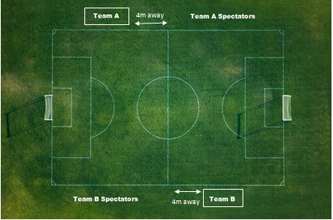

Discipline Procedure & Suspension Notification Process
When a player, team official, or spectator is ejected from a game, the game sheet and referee report will be received by the EMSA Office and the EMSA League Director will impose the disciplinary action required based on the referee’s report as per EMSA Rules and Regulations.
The main contact for the team will be notified of the suspension details via email from the EMSA Portal within a few days of the game’s completion. This email will contain the reason for the red card/ejection and the length of the suspension. Suspensions issued as a result of spectator misconduct are to be served by the main team official, as listed on the ASA roster unless the spectator is identified to EMSA by the team.
Team officials are responsible for enforcing all suspensions regardless of receiving email notification. Please contact the EMSA office if you haven’t received any notification prior to your next game.
All suspensions are issued in accordance with the Rules & Regulations and based on the report submitted by the referee. The EMSA staff do not have the authority to change a suspension.
Red Card suspensions are automatic and hold a minimum one (1) game suspension. Any suspension that is 2 games in length or longer can be appealed to the EMSA Discipline Committee. Any attempt to alter the conditions of the suspension by the team official must be made in the form of an official appeal. This appeal is to be submitted, in writing, along with the $100 appeal fee, to the EMSA Discipline Director at the EMSA office within 48 hours of the notification being sent from the EMSA Portal. There are no appeals granted for one (1) game suspensions, and/or, for cautionary offenses (i.e. no appeals for yellow cards issued).
All yellow cards, red cards, team official ejections, spectator ejections, etc. during incomplete games will still be valid and stand as is. Discipline will be issued for these infractions regardless if the game was fully completed or not.
If a team official is suspended they cannot be anywhere in the vicinity of the area (including parking lots or nearby/adjacent streets) of the area where the game is being played. They are not permitted to be near the outdoor field from 30 minutes before until 15 minutes after the game.

Players and Team Officials Serving Suspensions – Game Attendance
Players who are serving a suspension may attend their team’s games as a spectator only. They are not permitted to have any team interaction or be in the technical area/bench area. They are not permitted to sit on the bench and must sit with the spectators for entirety of the game.
Team officials who are serving a suspension cannot be anywhere in the vicinity of the area (including parking lots or nearby/adjacent streets) of the area where the game is being played. They are not permitted to be near the outdoor field from 30 minutes before until 15 minutes after the game.

For a complete list of Registration Violations, Game, Player and Team Official Discipline/Violations/Suspensions please visit the EMSA Rules and Regulations on the EMSA Website at: https://emsamain.com/wp-content/uploads/2021/04/EMSA-Rules-and-Regulations-v2021-2022.pdf

Player Unserved Suspension Games at Season Conclusion

- Discipline requiring suspensions affecting the end of the season will be distributed in the following manner and may be appealed as per the EMSA Rule book:

  - Discipline for Red Cards under section 6.5(2) (Violent Conduct) shall be served during the remaining league games, then any post season play the team is eligible for and then the following season the player is registered in. The suspension will be served in that order and carried through all three situations if required.

  - Discipline for Red Cards or two Yellows for offences that are considered nonviolent in nature and cannot be completed during the remaining league games will be referred to the Discipline Committee. The Discipline Committee will decide if the discipline shall be served in post season play, EMSA Sanctioned Tournaments, or the following season the player is registered in.
Team Official Unserved Suspension Games at Season Conclusion

- Discipline requiring suspensions affecting the end of the season will be distributed in the following manner and may be appealed as per the EMSA Rule book:
- Discipline for team officials shall be served during the remaining league games, then any post season play the team is eligible for and then the following season the official participates in. The suspension will be served in that order and carried through all three situations if required.

Violating Suspensions
Any person(s) found in violation of their suspension will be brought before the EMSA Discipline Committee for further action. The violation of any suspension may result in up to a one (1) year suspension from EMSA.
Protest of Game of Results
Protests of game results must be submitted in writing, along with cash/a money order/a cheque/an E-transfer/ payment by credit card in the amount of $75.00, to the EMSA League Director within 24 hours of the game being completed. Should the game results be overturned as a result of the protest, the administration fee will be refunded.
Questionable points of facts/points of view of the game official(s) will not be considered for protest.
Appeal Procedure
Appeals of decisions are to be submitted in writing - within 48 hours of the decision notification being sent (excluding weekends and holidays), along with cash, a money order, a cheque or payment with a credit card in the amount of $100.00 to the EMSA Discipline Director at the EMSA Main office.
Appeal fees will be refunded in the event that the individual in question has been completely exonerated by the EMSA Discipline Committee.
Hearings of appeals will be heard within ten (10) days thereafter (excluding Saturdays, Sundays and legal holidays).
The suspended individual must be present at the appeal hearing and can bring up to three additional witnesses to the hearing. No recording devices are permitted during the hearing. If the suspended individual fails to show for the hearing, they are automatically indefinitely suspended from all soccer related activities and must request a meeting with the Discipline Committee. An administration fee will be issued for the no show.
Concerns/Feedback on Referees
Questions and/or concerns pertaining to game officials can be sent to the referee assignor of that Zone/Club. Contacts are on page 3 of this handbook.
Tie Breaking Procedure (EMSA league play only)
When there is more than one (1) team at the end of a round that has accumulated the same number of total points within their division/group/tier, a tie breaking procedure is required in order to determine which team has the higher standing. The following are the procedures used to determine team standings.
Two (2) Way Tie
- Head to Head Game(s)

The winner of the game(s) between the two (2) teams will determine the higher ranking team. Ex. Team A & B are tied. The EMSA League Director will look back at the records to view the game results for the game(s) where Team A played against Team B. The winner of this/these game(s) will be considered to be in higher standing. Should the teams remain tied, the EMSA League Director will proceed to step 2 in the procedure.

- Total Goal Differential

The total goal differential is determined by subtracting the total number of goals scored against each team by the number of goals scored in the favor of each team, within the round in question only. The team that has the greater goal differential will be considered to be in higher standing. Should the teams remain tied, the EMSA League Director will proceed to step 3 in the procedure.

- Least Goals Scored

The team which has the fewest number of goals scored against them, within the round in question only, will be considered to be in higher standing. Should the teams remain tied, the EMSA League Director will proceed to step 4 in the procedure.

- Penalty Kicks

The EMSA League Director will schedule a place and time for penalty kicks to be made between the two (2) teams. Teams and game officials will follow the appropriate procedure for penalty kicks.
Three or more (3+) way tie
- Total Goal Differential

The total goal differential is determined by subtracting the total number of goals scored against each team by the number of goals scored in the favor of each team, within the round in question only. The team that has the greater goal differential will be considered to be in higher standing. Should the teams remain tied, the EMSA League Director will proceed to step 2 in the procedure. Should a team have a different total goal differential than the others, they will be removed from the procedure at this stage, the teams that remain tied will continue into step 2 of the tie breaking procedure.

- Least Goals Scored

The team which has the fewest number of goals scored against them, within the round in question only, will be considered to be in higher standing. Should the teams remain tied, the EMSA League Director will proceed to step 3 in the procedure.

- Penalty Kicks

The EMSA League Director will schedule a place and time for a single round robin of penalty kicks to take place between the remaining teams. Teams and game officials will follow the appropriate procedure for penalty kicks.

Post Season Information
Post season information will be emailed to you, as soon as it becomes available.
Teams are responsible for informing themselves on the post play information for their division.
Community - Post Season
The Post Season Commitment Form (on EMSA website) indicates whether or not your team will be participating in the applicable post season competition, should they quality. This form must be downloaded from the EMSA website, completed and submitted to the EMSA Community Program Director by Friday, June 3, 2022.
Club Teams - Post Season
A Club Post Season Commitment Form must be downloaded from the EMSA website, completed and submitted to the EMSA Club League Director by date: June 3, 2022.
Post Season – Non EMSA Member Teams
Non EMSA Member teams are not eligible to participate in the post season Provincials competition through an EMSA berth. Non Member teams, however, may participate in the EMSA City Finals and *All Star competitions should they be in a division that qualifies. A post season commitment form must be submitted by the deadline to advance. . * Non EMSA Member teams can choose to participate in the EMSA All Star event provided that they are not already attending a Provincial competition through their own District’s berth.

Post Season Competitions
Community League:
U9 – U19 City Finals: July 4 – 10, 2022
Tier 5 All Star Games: July 23, 2022
U13 – U19 Tier 4 Provincials: July 22 – 24, 2022
Club League:
U9 City Finals: July 4 – 10, 2022
U11 Tier 3 City Finals: July 4 – 10, 2022
U13 – U17 Tier 1 Provincials: August 12 - 14
U13 – U19 Tier 2 & 3 Provincials: August 12 – 14, 2022
*no post season for U11 Tier 1 and U11 Tier 2 due to season extension
Player Transfers/Registration
The process of transferring/registering a player must begin with your zone/club office/registrar. Should further assistance be required, please contact the EMSA Main office.
Transfer Deadlines:
Tier 1: July 29, 2022
Tier 2 & 3: July 22, 2022
Tier 4: July 1, 2022

EMSA Ivor Dent Sports Park & EMSA Charpentier West Complex
Dedicated Rain Out Line: 780.490.5789 updated by 3pm weekdays and 10am weekends
EMSA has scheduled some league games at our private facilities. Ivor Dent Sports Park is located at North East corner of Ellerslie Road and 50 Street in the South end of the City. Driveway access via the traffic light on 50 Street (address 503 - 50 Street). We have a total of 8 full size fields at the Ivor Dent Sports Park. The EMSA Charpentier West Complex is located at 10058 231 Street NW. West of the River Cree Casino, the EMSA West Complex has 12 fields with an additional 8 being seeded. 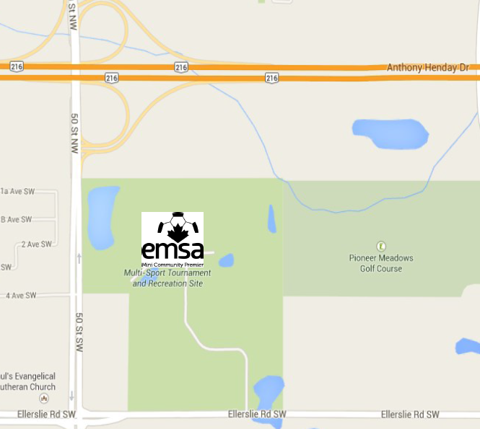 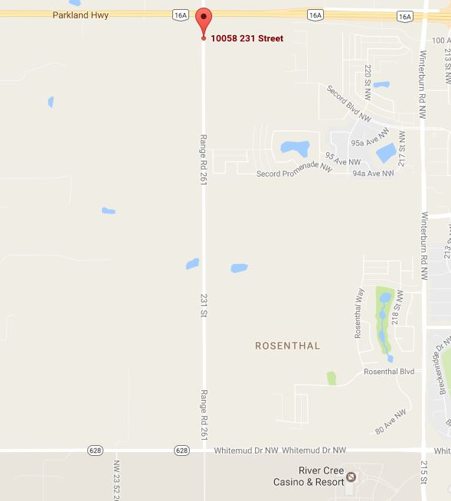
Ivor Dent Sports Park EMSA Charpentier West Complex
Please note the following information about your games at the Ivor Dent and EMSA West Charpentier Complex:
• Pets/Dogs are NOT permitted anywhere on the Complex properties (with the exception of service animals with proper identification). Ensure your player’s parents/guardians are aware of this rule.
• Based on their current condition, the fields will have roving field numbers. Please look for the EMSA signs or banners with the field numbers on them that coincides with the field number on your schedule. What is field #1 one week may not be field #1 the next week.
• Fields are available only ½ hour prior to your game start. Please do not go on the field any earlier than this.
• There is a very costly underground irrigation system running throughout the entire Ivor Dent Sports Park. This means that ABSOLUTELY NOTHING can be staked or pinned into the ground/grass such as pop up tents, umbrellas, etc. Please ensure your spectators are aware of this as teams will be held responsible for the cost of any damage caused to the system if they or their spectators are caught with items pinned into the ground.
• All cigarette butts and garbage (including decomposable items) must be disposed of properly. Please either place all garbage into one of the provided receptacles or take it home with you to dispose of.
• Teams will be held responsible for the cost of cleaning up any garbage left behind from their team or their spectators.
• Sunflower and other shelled seeds/nuts are strictly prohibited. Teams and spectators are not permitted to have them anywhere on the Complex premises. An administration fee may be issued to the team for violating this rule.
• Goal nets and all required flags will already be on site and set up for you. No need to bring your own.
• If you have a later game at either Complex, many referees will be taking care of the early game on a different field number. Once that earlier game is complete, they will make their way to your game.
• Parking is enforced by by-law. Please ensure you are parking in designated spaces only. Please do not park anywhere on the grass, field areas, driveways or roadways.
• Please do not warm up or practice on any other field other than the one you are assigned to. Many of the other unoccupied fields may be on rest.
• Children who are at the Complex but are not playing MUST be supervised at all times by an adult.

Field Maps

All field contracts are held by individual zones/clubs. Please contact your zone/club for inquiries regarding fields in your communities.
A field map can be found on the website schedules by clicking the word “map” beside the field name:
Additionally, field maps and addresses can be found on the City of Edmonton website: https://www.edmonton.ca/activities_parks_recreation/sports-fields.aspx You will need to scroll about 2/3’s of the way down the page to see the links for the field maps.

Codes of Conduct & Others

Coach / Volunteer Code of Conduct

Coach / Volunteer Responsibilities:
- To remember that you are an ambassador for the Edmonton Minor Soccer Association [EMSA], your Zone, and your Community, as such, carry oneself with respect, dignity and pride.
- To accept and work within all parameters set forth by the EMSA. To act in accordance with the Aims and Objectives set forth by EMSA.
- To demonstrate a commitment to a role chosen (coach, assistant coach, team manager, etc.).
- To act in accordance with all EMSA Bylaws Rules, Regulations and Policies.
- To carry out one’s duties and responsibilities in a manner exhibiting the utmost professionalism, dignity and respect.
- To respect and honor the EMSA Codes of Conduct.
- To carry out one’s responsibilities efficiently, accurately and to the best of one’s ability.
- To be accountable for the behavior of one’s team (if affiliated to one) including all its coaches, players and parents.
- To be accountable for all team-related activities including the accurate completion and timely submission of game sheets, the proper registration of players, the proper use of trialist players and the meeting of all league imposed deadlines.
- To respect the authority and dignity of ALL EMSA game officials including game referees, Board of Directors, staff and other volunteers.
- To comply with any mandates handed down, including all player / coach suspensions.
- To treat all EMSA Board of Directors, staff, fellow volunteers / coaches, players and parents with the utmost dignity and respect.

Coaches' Code
- Soccer is a game for happiness
- The laws of soccer should be regarded as mutual agreements, the spirit or letter of which no one should try to avoid or break
- Visiting teams and spectators are honored guests
- No advantages except those of superior skill should be sought
- Official and opponents should be treated and regarded as honest in intention
- Official decisions should be accepted without looking angry no matter how unfair they may seem
- Winning is desirable, but winning at any cost defeats the purpose of the game
- Losing can be a triumph when the team has given its best
- The ideal is the greatest good to the greatest number
- In soccer, as in life, do unto others as you would have them do unto you

Players' Code
- Play the game for the game's sake
- Be generous when you win
- Be gracious when you lose
- Be fair always, no matter what the cost
- Obey the Laws of the Game
- Work for the good of the team
- Accept the decisions of the Officials with good grace
- Believe in the honesty of your opponents
- Conduct yourself with honour and dignity
- Honestly and wholeheartedly applaud the efforts of you teammates and opponents

Parents' Code
- Children have more need for example than criticisms.
- Make athletic participation for your child and other a positive experience.
- Attempt to relieve pressure of competition, not increase it. A child is easily affected by outside influences.
- Be kind to your child's coach and officials. The coach is a volunteer giving personal time and money to provide a recreational activity for your child. The coach is providing a valuable community service, often without regard other than the personal satisfaction of having served their community.
- The opponents are necessary friends. Without them your child could not participate meaningfully.
- Applaud good plays by your team and by members of the opposing team.

Spectator Responsibility
Please remember teams are responsible and head coaches will be held accountable for the behaviour of their spectators/parents.
Emergency Contact Information
It is recommended that all team officials keep a list of emergency contact numbers on who to call for their players and other team officials in case of emergency. Important information should be also be known and listed about all persons such as important medical information like heart conditions, diabetes, hypertension, serious allergies, etc.

This book is an excerpt of EMSA’s rules, regulations and policies. For the complete listing of EMSA Rules & Regulations please visit:

www.emsamain.com
NOTES:
____________________________________________________________________________________________________________________________________________________________________________________________________________________________________________________________________________________________________________________________________________________________________________________________________________________________________________________________________________________________________________________________________________________________________________________________________________________________________________________________________________________________________________________________________________________________________________________________________________________________________________________________________________________________________________________________________________________________________________________________________________________________________________________________________________________________________________________________________________________________________________________________________________________________________________________________________________________________________________________________________________________________________________________________________________________________________________________________________________________________________________________________________________________________________________________________________________________________________________________________________________________

